THE UNOFFICIAL STORY AND THE PEOPLE WHO PAINT IT: AN INVESTIGATION OF URBAN ARTISTS’ MOBILIZING POWER IN OAXACA AND MEXICO CITY

by
KENDRA SIEBERT

A THESIS

Presented to the Department of Journalism and Communication
and the Robert D. Clark Honors College
in partial fulfillment of the requirements for the degree of
Bachelor of Arts

June 2019

An Abstract of the Thesis of
Kendra Siebert for the degree of Bachelor of Arts
in the Department of Journalism and Communication to be taken June 2019

Title: The Unofficial Story and the People Who Paint It: An Investigation of Urban Artists’ Mobilizing Power in Oaxaca and Mexico City

Approved: _______________________________________

Peter Laufer

Although parietal writing – the act of writing on walls – has existed for thousands of years, its contemporary archetype, urban art, emerged much more recently. An umbrella term for the many kinds of art that occupy public spaces, urban art can be accessed by whoever chooses to look at it, and has roots in the Mexican muralism movement that began in Mexico City and spread to other states like Oaxaca.
After the end of the military phase of the Mexican Revolution in the 1920s, philosopher, writer and politician José Vasconcelos was appointed to the head of the Mexican Secretariat of Public Education. There, he found himself leading what he perceived to be a disconnected nation, and believed visual arts would be the means through which to unify it. In 1921, Vasconcelos proposed the implementation of a government-funded mural program with the intent of celebrating Mexico and the diverse identities that comprised it. The murals, which were initially painted by pioneering artists Diego Rivera, José Clemente Orozco, and David Siqueiros, were meant to be more than just aesthetic – they were expected to create a new nationalist identity which would ultimately support the government’s agenda and prevent civil discontent.
Today, the legacy of these three artists lives on across Mexico, but the conversations surrounding urban art are evolving – specifically, in terms of its function in times of collective mobilization. Throughout more recent social movements across Oaxaca and Mexico City, urban artists have seen new potential in urban art, and have used it to represent what is really happening, when major media sources may become censored and/or corrupt. These artists, who are of every age, come from every background, and act largely anonymously, have left behind a different story of the history of social movements and popular demonstrations – one that I posit is the “unofficial” story of Mexico.
This thesis is based on the question “What functions can urban art serve in social movements?” and is contextually rooted in two regions of Mexico: Oaxaca and Mexico City. Throughout the 12 chapters that follow, I explore the power of urban art in its influence on politics and culture through the perspectives of different artists working in Mexico. I raise questions about interpretation, authorship, commodification, censorship, and identity-formation. I discuss the relationship between urban art and gentrification. Ultimately, I attempt to get to the core function of urban art and argue that it is a valid area of scholarship in an increasingly digital age.

Acknowledgements
This project would not have been possible in the first place without the help of many people whom I have had the privilege to work with throughout my time at the University of Oregon. I would like to extend gratitude to my thesis committee members, who have worked with me in every stage of this multi-year process. Peter Laufer, my primary advisor and journalism mentor, first introduced me to the art of cross-cultural interviewing in 2016, and he has been a constant source of encouragement and support throughout every stage of my college career. Elizabeth Raisanen, my CHC advisor, talked me off a research ledge many times and connected me with funding sources that made this whole thesis possible. Juanita Devereaux, my second reader and most influential Spanish teacher, renewed my passion for learning Spanish and provided suggestions for where to conduct research across Mexico.
I want to thank the following instructors for all the wisdom they have shared with me throughout my four years at the University of Oregon: Barbara Mossberg, Courtney Munther, Lori Shontz, Tim Williams, Kathryn Thier, Julianne Newton and Nathan Whalen. I also want to acknowledge the financial support I received from the Undergraduate Research Opportunities Program (UROP), the Arlene E. Cole Scholarship donors, and the Humanities Undergraduate Research Fellowship (HURF).
I am grateful for all the friends I have made throughout the past four years, especially my three housemates whom I met through the Clark Honors College: Fiona de los Ríos motivated me to dig deeper into my research and ask the questions that do not have simple answers; Brandon Orozco helped translate and transcribe my recorded interviews and ensured the perspectives of my interviewees could be accurately conveyed in writing; Dagny Daniel came with me to Mexico on my first trip and gave me the confidence I needed to return on my own. I am also grateful for my partner, Camila Salazar, who stuck with me despite the distance, and made me feel like my work was important, each and every day.
For my parents, Fritz Siebert and Cindy McKendry, I am especially grateful. They raised me with the belief that I could do anything I set my mind to, and now, I believe it more than ever. My Mexican Airbnb hosts, Tico and Edgar Villaseca, took me in as family in Oaxaca and Mexico City, respectively, and were a home-away-from-home throughout my journey. Above all else, I am thankful for the artists who shared their country, culture, art, perspectives and time with me – especially Abraham Leon, Pilar Fusca, Iván, Rogelio, DUSK, Paola Delfin, Katalina, and the Lopez family. This is for all of you.

Table of Contents
Chapter 1: Personal Reflections 1
Chapter 2: Project Origins 5
Chapter 3: Approach and Methodology 12
Methods 12
Research Questions 15
Vocabulary 16
Chapter 4: The Mexican Revolution 17
Chapter 5: Shaping a New National Identity 26
Chapter 6: Theoretical Functions of Urban Art 41
Chapter 7: Urban Art in 20th- and 21st-Century Social Movements 48
The Student Movement of 1968 48
Oaxaca Teachers’ Strikes of 2006 56
Ayotzinapa Movement of 2014 64
Chapter 8: Oaxaca Today 70
Chapter 9: Mexico City Today 78
Chapter 10: The People Behind the Art 88
Chapter 11: The Intersection of Urban Art and Gentrification 96
Chapter 12: Conclusion 100
Appendix 103
Bibliography 111

List of Accompanying Materials
- Photographs displayed at an exhibition in Allen Hall Spring Term, 2019.

Chapter 1: Personal Reflections
On the morning of December 28th, 2018, President Donald Trump threatened to entirely close the border between Tijuana and San Diego, if denied the funding from Congress to build his wall. That evening, I left Portland, Oregon, on a plane to Oaxaca, Mexico. I was returning to Oaxaca for my second time in three years, eager to continue my investigation of urban art and the artists who make it. I had no fear of being denied entry at Mexican immigration. My trip was being funded by the University of Oregon, and as I saw it, it was time for a new research adventure. But as I looked around, I couldn't help but be aware I was coming from a country that granted me more privileges than many others.
When I landed in Guadalajara, these thoughts were pushed out by the travel anxiety I am more accustomed to – Would I make my next flight? Was there time to get breakfast? Was my Spanish where it needed to be to make this whole trip work? I hustled through security and found my next gate with plenty of time to eat a crack-of-dawn breakfast. What I did not foresee, though, was meeting Julio and sharing our stories over identical room temperature Subway sandwiches.
Julio was born in Oaxaca, but has been living in Portland for decades now. He told me about his wife and his two children, all of who had previously lived with him in Oregon, but who had been forced to move back to Mexico the year before due to expired visas. Having not seen his family since September, Julio was visibly excited to be reuniting with his family for a belated Christmas celebration – he looked more through me than at me – when talking about it all. Though his trip was only scheduled to be 10 days long, Julio lit up while thinking about it. My thoughts turned back to my own agenda, then, which would involve a three-week stint in Oaxaca and two months in Mexico City.
In that moment, I thought about the ways that our lives differed because we were born on different sides of the border. This same thought stayed with me in nearly every interaction I had with Mexican artists throughout the following few months. For many of them, they had had their work accepted for exhibition in the United States, but they were unable to celebrate the accomplishment in person because they did not have time to apply for a temporary visa (or could not afford to). I could travel freely between these two countries as I pleased – the border was a permeable thing for me, but it was impenetrable for others.
I begin with this anecdote because one of the primary questions that has been at the core of my research process is: Why me? Am I, a gringa from Portland, Oregon, an outsider looking into a culture that is not mine, the “right” person to be doing research about urban art and social movements in Mexico? Can I contribute anything new to the field of knowledge surrounding it? And most of all, do I have something to give back to the artists who have offered up their time and perspectives and have opened their homes to me?
University of Oregon professor Lynn Stephen somewhat speaks to this in her book We Are the Face of Oaxaca: Testimony and Social Movements, which informed a great deal of my own research. A cultural anthropologist who has spent many years researching social movements in Oaxaca, Stephen has experienced her own set of challenges in reconciling with her own identity as a researcher who can come and go as she pleases. Still, Stephen has found that even the greatest differences that exist between herself and her interview subjects “do not erase [her] capacity and responsibility to engage in a politics of accountability with those around [her]” (21). This point of view struck me when I first encountered it, and has since made me more confident in my decision to do a thesis on Mexican urban art.
I have done what I can to prepare myself to do this work, from studying journalistic cross-cultural interviewing, to taking Spanish courses and following Latin American news. I am constantly checking myself and my privilege to ensure that my intentions show through in every part of my research. Additionally, I feel a responsibility to do a thesis centered in Mexico at a time with such rampant discrimination, both against the people who live across the border and American citizens with Mexican ancestry. I want to prove to the people that I met in Mexico that close-minded, xenophobic people living in the U.S., do not represent everyone in our country, but instead, only a segment of the population.
The chapters that follow were predominantly shaped by the many people I met and interviewed in Oaxaca and Mexico City, as well as faculty and colleagues at the University of Oregon and elsewhere. This thesis is the result of many forces colliding together, not just dating back to 2016 when the idea for this project was consciously born, but years before that – to when I roamed the streets of southeast Portland as a kid, observing the art that filled the streets around me and wondering what it all meant. I still may never fully understand what a piece of art means by looking at it, but I am confident that I will always remember its worth and view it as a legitimate source of knowledge.
I will also remember art’s capacity to connect people. In this time when Mexico and the U.S. feel deeply divided, art is something that can bring our nations together – something to use to overcome the barrier between us and achieve solidarity. The artists I was lucky enough to meet in Oaxaca and Mexico City understand this, while many of us in the U.S. still have a long way to go. Rather than use walls as dividers, Mexican urban artists are using them to connect. They tell the unofficial stories of their communities, communicate forms of cultural testimony, and preserve collective memory, all through their walls. It’s time we stop building walls, and start seeing them, instead.

Chapter 2: Project Origins
Urban art exists around the world and takes many forms; it also carries different meanings for different people. Throughout my research, I came across the various, often-contradictory definitions of urban art and ultimately identified arts author Tristan Manco’s version as the most representative of the urban artists’ perspectives I learned from over the last few years. In Make Your Mark: The New Urban Artists, Manco defines urban art as “work that is influenced by street art and graffiti cultures, and artists who use the urban environment as their platform.” This is the concept I am referring to, every time I mention urban art in this project.
Initial Curiosity
As a native of the inner-Southeast Portland area, I grew up surrounded by urban art. I remember seeing artists paint the walls of the city in the nighttime with images as eclectic as skeletons and donuts. I also watched small business owners struggle to scrape graffiti off their storefront windows in the early mornings as I passed by on the 14 bus. But it was only when I studied cross-cultural interviewing and storytelling under Professor Peter Laufer in Rosario, Argentina, that I began to question the purpose of urban art and the intentions of the artists who create it.
I arrived in Rosario on June 16, 2016 and quickly came to understand that the city of more than 1.2 million people was also home to a wealth of public art. Seemingly every block was marked with something, be it anti-government graffiti tags or large-scale murals, and once again, I found myself longing to understand what it all meant. Every day, I would walk to class taking new streets and panning the surfaces around me, always finding something new and thinking of new questions to ask. Every evening, I would reflect on what I had seen and on my shifting relationship with the space around me. As I learned more about Argentina’s history and the many changes the country has undergone, I began to find meaning in the walls around me – the walls that have withstood even the greatest atrocities.
The Dirty War was a period of state terrorism that began in 1976 and lasted until 1983. In this seven-year span, thousands of Argentine activists were kidnapped and disappeared. To date, 30,000 desaparecidos are still unaccounted for. In the search for their lost children, the Madres formed, an association of Argentine mothers who began to march in 1977 at the Plaza de Mayo in Buenos Aires in defiance of the government’s state terrorism. To this day, the Madres march every Thursday at 3:30 pm, wearing white head scarves to symbolize the diapers of their lost children and holding their childrens’ portraits to show they have not given up looking for them.
Through their weekly mobilizing, the Madres are challenging the government to recognize its past atrocities. For Taty Almeida, an 86-year-old Madre whose 20-year-old son, Alejandro, disappeared in 1975, “Argentina’s new government wants to erase the memory of those terrible years” by putting the brakes on the trials of the former dictatorial government members (Goñi). The Trial of the Juntas began in April 1985 and was the first major trial held for war crimes after the Nuremberg Trials following World War II. Since then, nearly 900 former members of the junta have been tried and convicted of crimes, many involving human rights abuses, but that will never bring back the people who were taken – the lives that were lost.
Still, even decades later, Almeida’s fear of the Argentine government’s rewriting of its history motivates her to keep marching in pursuit of answers. “This struggle began when we were in our 40s. Now, 40 years later, we have to start all over again,” Almeida reflected (Goñi). That being said, the weekly Madre marches are not the only way Argentines are trying to challenge the government’s account of what happened during the Dirty War. Artists are also using the walls around them to tell the “unofficial” story.
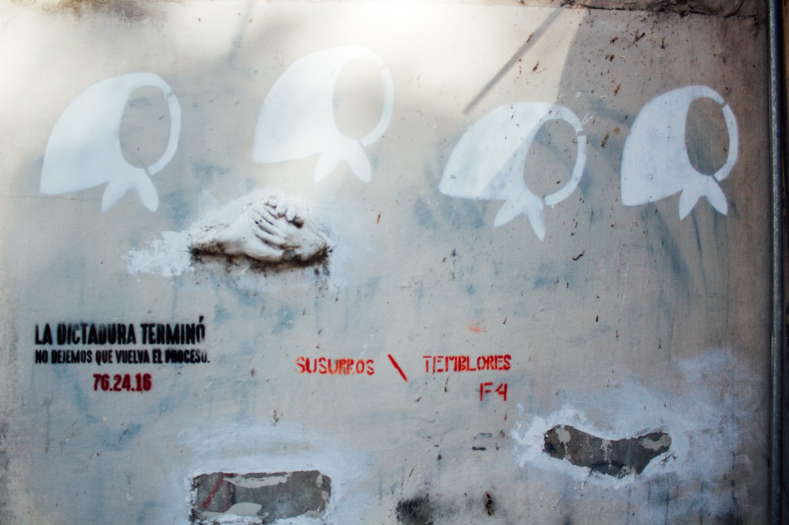
This wall features the symbol of the Madres and reads, “The dictatorship ended. Don’t let the process come back.”

Once I knew what the Madres movement was about and understood the symbol of the head scarf, I began to notice it everywhere. By spray painting stencils like the one used in the image above, artists are able to cover a wall in a matter of minutes and can do so with less risk of being seen and stopped than when using other approaches. The following photograph features more of these stenciled Madres symbols, and I believe it makes a powerful statement by providing the viewer with multiple levels to interpret – one of the reasons the arts can be a particularly effective form of communication, as I will explore throughout this thesis.
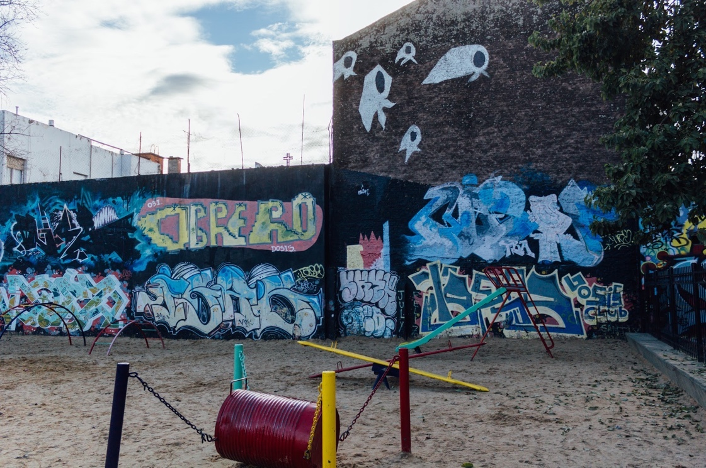
Before this photograph was taken, a young boy and girl were playing on the structures while a guardian looked on. Then they left, leaving the playground eerily empty.

Argentina is where I first recognized that urban art has the potential to generate a dialogue and challenge the false narrative constructed by those in power. I clung to the belief that urban art is intrinsically democratic, in the way that it gives people of all backgrounds a platform to express their ideas, regardless of artistic experience or personal opinion. Still, this was an early stage of my research, and the more I read about and connected with urban artists, the more I found myself questioning whether the medium is really an equalizer. Though I believe that urban art has the power to draw attention to and impact culture, preserve cultural memory, and tell unofficial stories, it can be manipulated depending on the agenda of the artist and whoever is paying them.
Compared to many other types of art, urban art has only become an area of study in recent years. However, because of its visibility in public areas, as well as the subject matter often conveyed through it, I believe urban art is an important topic to study – especially in places experiencing human rights violations and social unrest. Across languages and cultures, art can be a tactic to convey messages that influence public opinion and greater society. But is it an effective one? Does it deserve to be trusted? And how does its ephemeral nature affect its ability to communicate a message and reach a wide audience?
These are some of the questions I began to consider after my time in Argentina, and after returning to the States in August 2016, I embarked on a quest for answers. I focused on deepening my understanding of Latin American art more generally, looking outside of Argentina to get a sense of other urban art hotbeds, but it was only later that year that I decided to entirely focus my research efforts within Mexico, the country considered by the critics I studied as the birthplace of modern muralism.
Mexico in a Glimpse
With more than 130 million people living within it, Mexico is the tenth most populated country in the world and is categorized as “pluricultural.” The country has one of the largest and most diverse indigenous populations in all of Latin America. Its capital city, Mexico City, also referred to as Distrito Federal (DF), has a population of 21.2 million people, 8.9 million of whom live within the city itself – already substantial in size, but even more so when compared to the more southeastern region of Oaxaca (World Population Review).

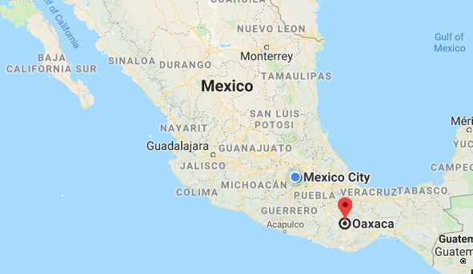
Source: Google Maps

Oaxaca and Mexico City are separated by a mere 227 miles, but their compositions are vastly different. With a total population of roughly 250,000, Oaxaca is only a fraction of Mexico City’s size. In fact, it does not even make the list of Mexico’s twenty-most-populated cities. Still, Oaxaca has been found to be the most culturally diverse state in Mexico. According to the 2005 inter-census population count, more than one million people in Oaxaca spoke at least one indigenous language (Burton). This presence of a larger indigenous population and the many languages that come as a part of that – ranging from Mixtec, to Zapotec, to Mazateco and others – set Oaxaca apart from the more globalized Mexico City.
Oaxaca and Mexico City differ significantly in terms of population and demographics, but despite these differences, they have a shared history of social movements, and with it, political urban art. Because urban art has played significant and unique roles in both Oaxaca and Mexico City dating back to the early 1900s, I ultimately selected them as the specific sites for my research. As I will argue throughout this thesis, urban art reflects the social context it comes out of. Therefore, to understand the art itself, I first had to get a sense of Mexico and the factors that made it what it is today.

Chapter 3: Approach and Methodology
As I have already mentioned, I first conceived of this project in summer 2016. Since then, I have employed different methods throughout the various stages of my research. I created a standard interview method that was approved by the Institutional Review Board (IRB), first using it in August 2017 and later refining it for my return trip in winter 2019.
Methods
My objective with this thesis was never to speak for the artists in Oaxaca and Mexico City, but to bring in their voices and use their perspectives as the authority on urban art in Mexico. For this reason, my thesis is largely shaped by the conversations I had with urban artists, which predominantly took the form of one-on-one interviews. To first find these urban artists, I reached out to University of Oregon faculty and other artists living in Oregon. Peter Laufer (Journalism), Lynn Stephen (Anthropology) and Gabriela Martínez (Latin American Studies) helped me build connections with some of the artists who have been especially formative in my research process.
I first came to Oaxaca and Mexico City in August 2017. Throughout the three weeks I spent there, I conducted one-on-one interviews, which, fortunately for me, were often in artists’ studios, public parks, or pulque bars (note: pulque is a traditional beverage of central Mexico that is made from the fermented sap of the agave plant). I entered each of my interviews with an audio recorder, a pen and paper, a mini-dictionary, and a list of questions to ask. These questions related to artists’ backgrounds, trajectories, motivations for creating urban art, and opinions about its political nature. The artists I spoke with identified with different political and social movements such as Zapatismo and feminism. Not all were born in Mexico. While a few artists had formal training in fine arts, many others were self-taught. After completing my interviews, I photographed the artists in their studios or in other environments – pending their consent to being photographed – and captured photographs of their work if it was reachable by public transit.
When my first trip came to an end, I relied heavily on social media to keep in contact with the artists I had already interviewed and to find new prospective interviewees. Instagram and Facebook were the platforms I used the most to connect with new artists who identified across a spectrum of political affiliations and personal beliefs. Throughout the year that followed, I grew my network of individual artists and collectives, many of whom I was able to interview on my follow-up trip that started in Oaxaca on December 28, 2018.
While in Oaxaca for the second time, I observed a shift in the conversations I had with interviewees. My questions became more about the function of urban art – as a conversation generator or social mobilizer – and the responsibility artists had when creating public works. Through the process of interviewing artists multiple times a week, I began to tap into the topics they were most impassioned by and was able to understand what artists living in Oaxaca were especially interested in – or frustrated about.
I traveled to Mexico City on January 20, 2019 and took a similar approach there. Conducting interviews in Mexico City proved to be more challenging in some ways. I often had to travel much longer distances to meet with artists, which allowed me less time to spend with them. Because I had more time in Mexico City, I was able to space out my interviews more and take more time to look at the art across the capital in comparison to that in Oaxaca. This guided me to ask interviewees about festivals, an aspect of urban art that I have come to believe is quite important in this area of scholarship overall, because state-funded public works often have a different intended effect than the works of unsponsored individuals – as well as to inquire about other topics.
Outside of these more formal interviews, I spent a significant amount of my time getting to know artists on a personal level. One of the greatest challenges of this project was establishing boundaries in a culture that is, in some ways, quite unlike what I was previously accustomed to. Every artist I met was incredibly generous with their time. Of all the interviews I conducted in both 2017 and 2019, only a handful lasted less than an hour, and many led to follow up meetups at art exhibitions or cultural events. In a few cases, I developed close friendships with the artists I met, and we still talk regularly through WhatsApp and Instagram. Getting to know urban art and artists through both an academic and personal approach was one of the most rewarding elements of this thesis. I was able to gain an insider perspective – a look into the ways that artists live their lives day-to-day – and I am grateful to have experienced that.
Throughout my research process, I was also able to operate as a photographer. I photographed as much of the art I saw as possible in the hopes of making this thesis visually accessible for readers. Because urban art is the very backbone of my project, and even acts a primary text in some cases, I viewed the process of photographing the work I saw as crucial. I viewed everything in my surroundings from a creative point of view, whether through a lens or not, and eventually came to see preserving the urban art around me as another personal responsibility.
On my first trip in August 2017, I took thousands of photographs of the urban art I came across, the messages these pieces communicated, and the people who occupied the space around them. I also noted the location of each piece so that I could revisit them on my more recent trip. In winter 2019, I photographed the drastic transformation of some of the walls, and the comforting sameness of others. My photographs were temporarily exhibited in Allen Hall from April through May with the hope of giving Eugene viewers a sense of what the urban art scene is really like in Oaxaca and Mexico City today. Now, I will acknowledge that trying to capture the scope of urban art, both in terms of size and emotion, is simply not possible. However, this exhibition, as well as the images preserved in this thesis, will ideally do two things for viewers: 1) Challenge them to reconsider the perceptions they have of urban art and 2) encourage them to go see it for themselves.
Research Questions
My primary questions for urban artists included:
- What is your objective as an artist?
- What do you believe is the function of urban art?
- What role does urban art play in social movements, if any?
- Can urban art communicate the “unofficial” story of a place?
- Is all art in the public space inherently political? If not, should it be?
- Would you describe urban art as a form of cultural testimony, or something else?

Vocabulary
The following terms are ones that I believe are most important to know when reading my research, yet they are often the most difficult to distinguish from each other. The definitions I have provided pull from the concepts of the critics and artists I came across in my research, but I want to make it clear that there is just no one standard definition that aligns with every artist’s personal understanding. That being said, these are what I have identified as most the representative:
Graffiti: usually created without permission, and mostly involves letter-based tags and pieces, sometimes with characters and backgrounds as well.
Tagging: largely considered as a more aggressively territorial type of graffiti that is “based on claiming an area, ‘getting up,’ and taking out work by any rival crews or writers” (Walsh).
Street art: art created on surfaces in public places that is usually created as a means to convey a message or social commentary.
Urban art: work that is influenced by street art and graffiti cultures, and artists who use the urban environment as their platform.
Mural: typically covers the entire wall, top to bottom, and is painted with permission; the artists are usually paid to paint the wall and they sign it with their name.
Fresco: a picture made by painting on wet plaster on a wall or ceiling.

Chapter 4: The Mexican Revolution
As historian T.R. Fehrenbach puts it in his forward to Fire and Blood: A History of Mexico, “Mexico’s present makes no sense without Mexico’s past.” In other words, to grasp the meaning, function, and power of urban art today, it is crucial to first have a solid foundation of historical, contextual knowledge. The information that follows is what I believe is most relevant for understanding social movements and the role urban art can play in them. I draw the following information from guided interviews, documentaries, articles, and books, and I believe this context is essential to establish before engaging in a narrower discussion of urban art.
The Beginnings
After centuries of being led by Spanish rulers, Mexico won its independence in 1821. Yet as is described in the 2011 PBS documentary The Storm That Swept Mexico, Mexico faced instability and eruptions of conflict from that moment onward. In the Mexican-American War of 1848, Mexico lost half its land to the U.S. Two decades later, Mexico suffered additional setbacks with the invasion of France and its installation of a monarchy system. Still, the end of the 19th century is remembered as a period of peace – the calm before the storm.
In “Political Change and Stability in Mexico,” Paul Ganser describes the pax porfiriana, or the Porfirian peace, of the dictatorship of Porfirio Diaz from 1876-1910: “[It] was a period of order, progress, infrastructure expansion, economic growth, and modernization” that relied on an alliance constructed by Don Porfirio between large landowners, foreigners, businessmen, parts of the emerging middle class of small businessmen, merchants, professionals, and public and private white collar functionaries. These groups constituted a small minority of Mexico's population, but they shared in the benefits of Mexico's economic growth, urbanization, and modernization. The same was not true for the majority of Mexico's people – especially the urban poor and the rural peasants (131).
One narrator of The Storm That Swept Mexico describes the revolution as “a social process that is intimately related to the history of 19th-century Mexico.” Most central to this is his following claim: “What we’ll find is that there are two Mexicos.” The duality of the Mexican nation is largely what historians believe was the impetus for the Revolution. The country itself is sizeable, and the regions within it are spread out far and wide. The northern, central, and southern areas have their own distinct cultures and identities, and for some, they feel like different worlds entirely. Because of this separation of peoples and the lack of socialization across different populations, 19th-century Mexico was characterized by three key elements: the exploitation of indigenous peoples, racism, and classism.
El Porfiriato
Porfirio Díaz is a central figure of the Revolution, and the period of his dictatorship is remembered as el Porfiriato. In his biography of artist David Alfaro Siqueiros, Anthony White acknowledges one of the positive aspects of Díaz’s leadership: “Despite its strong-arm tactics, Díaz’s 35-year rule brought welcomed stability to a war-torn Mexico, encouraged foreign investment and fostered economic growth. New industries emerged, mining flourished and Mexico became the second largest oil producer in the world” (3). The expansion of the economy was accompanied by cultural advances, such as the building of more schools and other infrastructure.
White goes on to say that behind this facade of peace and progress “there were serious tensions and contradictions, which were about to tear the country apart.” It was in Mexico City, the modern-day capital of Mexico, that Díaz engaged in his corrupt political and social affairs. The dictator surrounded himself with a group of technocrats known as the cientificos, men who were responsible for writing legislation, putting together contracts with foreign companies, and fulfilling other important responsibilities. Between 1892 and 1910, these cientificos transformed from a creative to a dominant minority in Mexican political life (Breymann, 193).
In “Cientificos and the Collapse of the Diaz Regime,” Walter Breymann explains the shift that took place in this 18-year period. As “men of exceptional ability,” the cientificos were responsible for much of the progress made in the Diaz regime. However, in 1903, the group abdicated its position of critical opposition, abandoned its reform program, and was absorbed into the administration. The Cientificos began to share in the spoils of the regime, and, as “selfish defenders of a profitable status quo,” assumed a role characteristic of Dominant Minorities.
Through abandoning their liberal, reforming impulse and their original ideal of social progress for the good of the nation, they became increasingly materialistic, “turning their talents to converting their influential position within the administration into personal financial gain” (193). While members of Diaz’s regime grew wealthier, Mexico’s labor population became increasingly repressed. Wages were embarrassingly low, hours were excessively long, and education was a monopoly of the elite.
The Tides Begin to Turn
As Fehrenbach sets up in Fire & Blood, social revolution did not erupt spontaneously, or irresistibly: “First, the Porfirian political structure collapsed; the collapse led to the anarchy, and in the anarchy at last the long-banked fires of social misery, frustration, and racial tensions broke through” (482).
In the early 1900s, many large estates that originated from Spanish land grants and the pillaging of indigenous peoples generated a great deal of Mexico’s wealth. Known as haciendas, these estates functioned in a semi-feudal system, in which land workers operated in sugar plantations with horrendous conditions for benefits that were next-to-nothing. Morelos, a southern state of Mexico, was home to some of the most-profitable but least-humane haciendas, and after centuries of abuse, Morelos workers began to rebel. A Zapatista veteran interviewed in The Storm That Swept Mexico remembers how he and his fellow workers did not courageously join the revolution in defense of the nation or out of pride – rather, they rebelled out of necessity.
The general consensus about agrarian goals of the Revolution is this: agrarian reform was needed to end latifundia and promote a greater degree of land ownership among the land-hungry rural masses (Knox, 56).

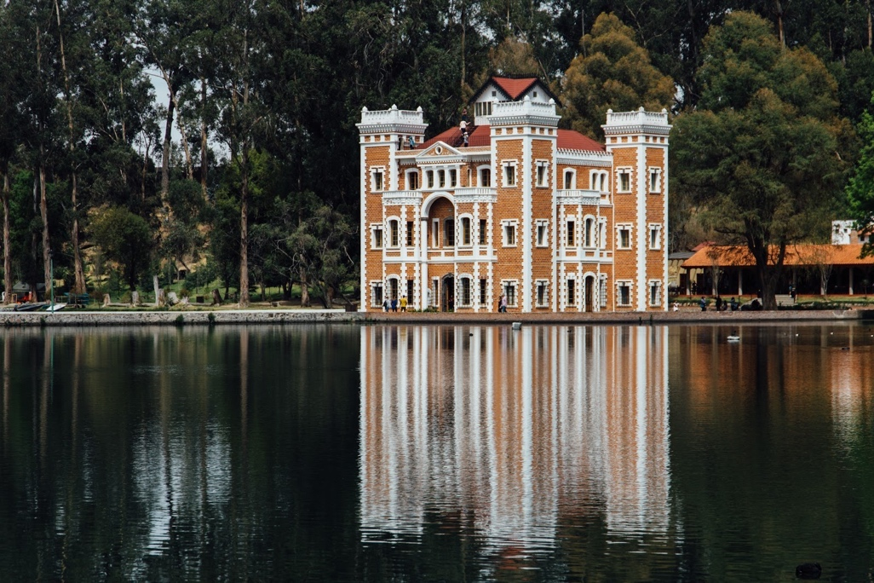
Chautla Hacienda owner Eulogio Gillow lost most of his land when the people of Mexico rose up against the Hacienda feudal system in the early 1920s. The hacienda still stands today.

At the same time, the north of Mexico also began to see uprisings as people demanded better conditions and the re-installment of their lands. Under Díaz, railroads were being put in across the country to help transport goods to other regions, but it was at the cost of the people whose lands were taken over. This produced bandits and free men who were unwilling to be laborers on the haciendas, and instead demanded better opportunities for themselves. Many of the people who joined the bands of revolutionaries in the north were those who had been stripped of their lands, as well as the children of those who were displaced (The Storm That Swept Mexico).
Conditions grew more tense with the Panic of 1907, a U.S. economic recession that caused farmers in northern Mexico to go broke and ushered in widespread hunger. Mexican miners who had been overworked and underfed began to strike in demand of the same wages their American counterparts received, leading to the intervention of 250 Arizona rangers, the killing of roughly 30 workers, and growing outrage around Mexico. Adolfo Gilly of the National Autonomous University of Mexico (UNAM) says, “If we look at the Porfiriato in terms of stability, economic growth and a strong ruling class, we’ll see one view of Mexico. If we look at it from the point of view of the oppressed indigenous people and workers, we see a different view. If you combine both views, what you find is great injustice. This is the Porfiriato.”
While lives were lost leading up to the revolution, the people of Mexico who wanted change gained something important – the realization that Díaz was unable to entirely control domestic affairs. All over the country, strikes broke out, from textile mills, to tobacco factories, to railroad yards. People were tired of witnessing cientificos profit at their own expense and adopted a new mentality: “Perhaps Díaz has been in charge long enough.” This idea was championed by Francisco I. Madero, a member of the Anti-Reelectionists and an important figure in Mexico’s history (The Storm That Swept Mexico).
In his book La Sucesión Presidencial, Madero criticized the 30-year dictatorship and called for new elections. In 1908, Madero went so far as to organize a national party that would compete in the 1910 elections, but was soon after arrested and jailed by Díaz. After Díaz was announced the winner of the reelection, Madero knew that free and honest elections were not an option under the current regime; in other words, it was time to revolt.
A Revolution
As Stuart Easterling describes in The Mexican Revolution: A Short History, when the opportunity presented itself in 1910, the combined political factors of privilege and corruption, abuse of political power, and a lack of political autonomy, produced armed revolt. Linking this political revolt with a mass uprising of the Mexican peasantry is what ultimately produced the Mexican Revolution. In Chihuahua, the northern state of Mexico, Pancho Villa became one of the biggest threats to face Díaz. Described as a “rough and tumble outlaw-turned-revolutionary,” Villa embodied the spirit of the people in the northern states, having come from social violence and having been a minor outlaw earlier on in his life (The Storm That Swept Mexico). Villa learned artillery techniques, and everything related to military science, making him an iconic warrior, yet a relatable one. He began to put together an army to serve Madero that would help topple the Díaz regime, and he would later combine forces with Emiliano Zapata.
Zapata operated in the southern state of Morelos and was a danger to Díaz because of his demand for land reform. With this demand, he was challenging the whole notion of power and the way it should be structured and threatening the whole notion of how power would be organized in Mexico (The Storm That Swept Mexico). Zapata even carried around the ancestral claims to the land of his family and his followers in the region, further showing that it was the land itself that gave life to communities in Mexico. Essentially, both Villa and Zapata began a conversation of rights centered on two questions: Who had the right to lead? And did people have a choice in who they followed?
The Tiger
In the spring of 1911, Madero took on Díaz’s army at the Casas Grandes and continued his campaign north to the city of Juarez. After being threatened with U.S. involvement, Madero decided to retreat, but his revolutionary army generals Villa and Pascual Orozco (no relation to the artist) attacked the city nevertheless. They captured the border town and made it Madero’s capital, most importantly gaining a victory that chipped away at Díaz. When news of Díaz’s defeat spread to Mexico City, thousands of people gathered in the Zócalo, shouting for his resignation. Soon after, Madero paid Díaz a visit, and spared his life on condition that the dictator go into exile (The Storm That Swept Mexico). Diaz left behind the famous parting words, “Madero has unleashed a tiger. Now let’s see if he can ride it.” President after president has since tried to tame the tiger, but depending on whom you ask, no one’s done it quite yet.
Constitution of 1917
The Mexican Revolution finally neared its end with the organization of a Constitutional Convention and the creation of the Constitution of 1917. Ratified under the new president Venustiano Carranza, this constitution provided unprecedented rights for Mexico’s poor and working classes, by guaranteeing that only Mexican citizens own the natural resources above and below the ground, and by redefining rights themselves. Overall, the Constitution of 1917 was a statement of what people wanted for Mexico, but could not necessarily achieve. For Romana Falcón, instructor at el Colegio de México, “The constitution was like a map of the country we wanted. But that vision we wanted was never put into practice. It was never implemented.”
After realizing that Carranza was not dedicated to following through with the ideas outlined in the Constitution of 1917, Zapata felt Mexico was being betrayed again by those in power and accelerated his campaign against the government. In doing so, he put an even bigger target on his back that resulted in his being shot at and killed in a set-up ambush in 1919. Zapata’s death sealed Carranza’s own fate, too, as his loyal followers partnered with Álvaro Obregón to overthrow the current president. They succeeded, putting Obregón into power from 1920 to 1924, and officially closing the chapter of the revolution. What was needed next was a radical redefinition of what Mexico stands for as a nation, as well as more inclusive representation of the diverse peoples who make it up.

Chapter 5: Shaping a New National Identity
After the end of the military phase of the Mexican Revolution, the Mexican people were disconnected and polarized. Fehrenbach refers to this aspect of identity in Fire & Blood: A History of Mexico, saying “Mexicans’ central problem, that of identity, began with the Spanish Conquest, and it remained, because the Conquest was and still is the supreme fact of Mexican history” (579). This artistic explosion that came with the revolution was a sign of the desperate search for nativism was “a normal reaction and long overdue” (580).
Beginning with the creation of the Secretariat of Public Education in 1921, President Obregón implemented a social and cultural program involving education, literature and the arts that was intended to bring people together as one nation. He appointed José Vasconcelos to direct it as the Minister of Education. Vasconcelos identified the visual arts – specifically, murals – as the ideal medium through which to unify Mexico, largely because it was accessible for all people in a time when nearly 90% of citizens were illiterate.
Described as “a sort of cultural czar,” Vasconcelos appointed and dispatched cultural missions around the world, brought important cultural figures into Mexico from throughout the Hispanic world, and gave a host of artists their first chance at public recognition and status (Fehrenbach, 582). In 1921, Vasconcelos proposed the implementation of a government-funded mural program that he thought would showcase Mexico’s long history and unify people as members of one collective – one unified mestizo, or mixed-race, nation.
Vasconcelos selected Diego Rivera, José Clemente Orozco and David Siqueiros as the three artists that would initiate the mural movement in Mexico City and forge a new nationalist identity (Rochfort, 14). Remembered today as Los tres grandes (The Big Three), these Mexico-born artists carved out distinct names for themselves with their individual styles, techniques, and influences, and today they are recognized as patrimonial artists of Mexico. Under these artists, mestizo creativity drew consciously on its own heritage for the first time, and its practitioners, Los tres grandes, became world-famous (Fehrenbach, 583).
I will briefly discuss some of each artist’s defining characteristics and most influential works, but what I posit is most important to know about their legacy is this: these first Mexican muralists laid a foundation for political art in the public space that can still be witnessed across Mexico today. They act as an influence through their conceptual principles and their clear mission to make art for the people (Schacter, 98).
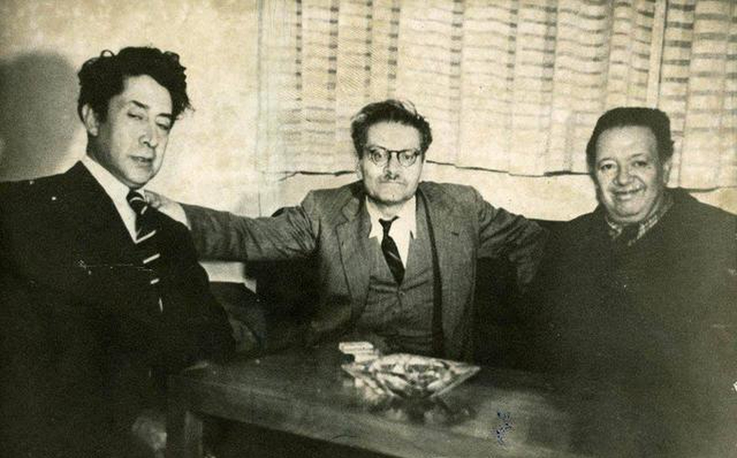
Siqueiros, Orozco and Rivera, the Big Three, photographed. Source: Cenidiap Archive, Mexico City.

Diego Rivera
Rivera is by far the most historically recognized mural painter of the early 1920s and also the most studied by historians and critics (Folgarait, 3). He was born December 11, 1886 in the silver-mining town of Guanajuato, Mexico. At the age of 10, he knew he wanted to be an artist, and began to study art full-time at the San Carlos Academy in Mexico City. After feeling dissatisfied with his training, Rivera traveled across Europe, studying with European artists including Picasso and Braque. In his time abroad, Rivera experimented with cubism and incorporated it into his early artistic style, but he experienced a major shift in style while studying Renaissance art in Italy (Ciok, 64).
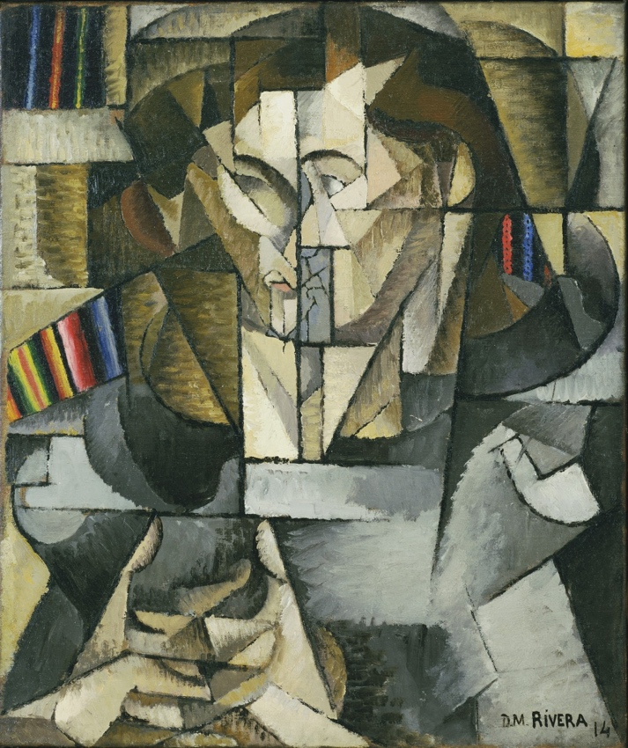
Rivera’s “Young Man in a Gray Sweater.” Paris 1914. Oil on canvas.
In 1920, Rivera discovered frescoes, mural paintings done on plaster, and found them to be well-suited for capturing his vision of art for the people. Soon after, Rivera returned to Mexico, where he drew inspiration from the Italian frescoes he had seen, as well as from his own unique vision. Rivera’s very first piece for the mural movement was “Creation,” which he completed at the Escuela Nacional Preparatoria in Mexico City in 1922. Overall, he painted 235 frescoes in this period, depicting Mexican history, the working class, and human and technological developments, as well as his perspective on the nation itself (Ciok, 64).

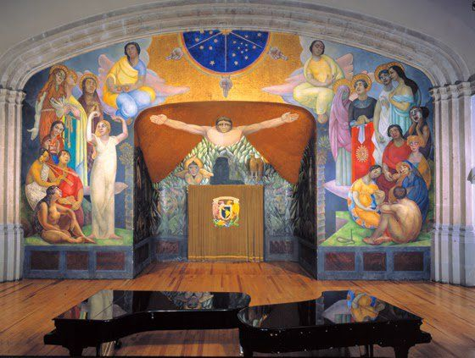
Rivera’s “Creation” covers over 1,000 square feet and tells Mexico’s origin story through mythological and religious motifs. Source: Unknown

Aside from his reputation as a prominent artist, Rivera was also known as a political figure. Rivera was a dedicated Marxist who expressed his political views through his art. In 1932, he traveled to the U.S. to create “Man at the Crossroads,” a commissioned painting in Rockefeller Center, but he offended Nelson Rockefeller by including a portrait of Vladimir Lenin within the mural. When requested to remove Lenin from the mural, Rivera refused, abandoned the project, and returned to Mexico. The original mural was destroyed, but Rivera repainted it in Mexico City, where he continued to enjoy his freedom of expression until his death in 1955.

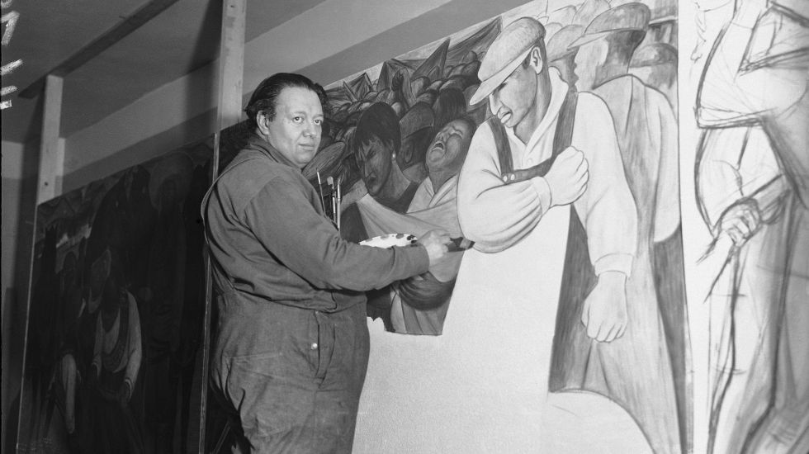
Diego Rivera photographed painting his mural “Baile en Tehuantepec.” Rivera created a legacy for himself as an artist focused on social elevation for the underrepresented. Source: Associated Press

José Clemente Orozco
Unlike Rivera, who was more of a romantic, Orozco was a realist and a prophet (Cave). He was unique among the Big Three in avoiding strongly partisan politics and especially leftist positions on the major social issues of his time (Folgarait, 4). As Damien Cave describes in his New York Times article “Mexico’s Not-So-Favorite Son,” “In a country of kisses on the cheek, Orozco chose confrontation. He painted the subjects of the day — revolution, workers, war, and religion — but with skeptical strokes, and dark colors. He often insisted on showing the world stripped of sentimentality, or laced with satire.” Orozco’s approach was informed by the artist’s early life, which began in Zapotlan el Grande, Mexico.
Orozco was born on November 23, 1883 to his father, a businessman, and his mother, a homemaker. A few years later, Orozco and his family moved to Mexico City, where he took night classes at the San Carlos Academy of Art. After contracting rheumatic fever in 1898, Orozco suffered more tragedy. His father died suddenly of typhus in 1903, leaving the young artist to quit school and begin a series of odd jobs to support his family. Only one year later, Orozco injured his left hand and eye in a chemical explosion, and had his hand amputated soon after.
Considering these beginnings, it is not surprising that Orozco was less interested in celebrating the advent of a New World after the Revolution, and more compelled by the miseries of armed fighting, the suffering of the dispossessed, and the violence that came from the miscegenation, or “colonial cross-breeding” that ultimately defines the Mexican people of today (The Museum of Modern Art (MMA)). Between 1910 and 1916, Orozco drew cartoons for the magazine El Hijo de Ahuizote and explored his identity as a politically oriented artist on the staff of La Vanguardia (Tuck). In 1923, Orozco painted his first mural for the Mexican government’s literacy campaign at the National Preparatory School and created more murals after – all but one of which were located indoors – before moving to the U.S., where he resided from 1927 to 1934.
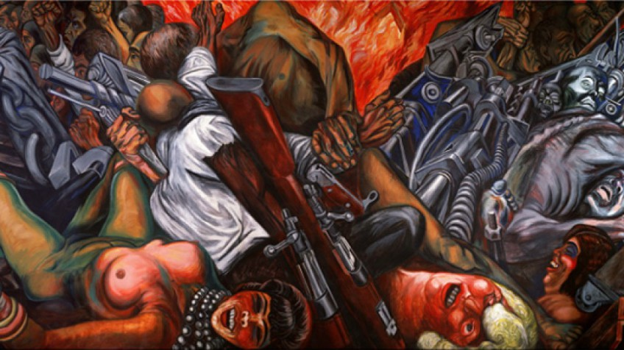
Orozco painted “Katharsis” on the gallery floor of the Palace of Fine Arts in Mexico City in 1934. Its themes include individuality, humanity, war, destruction and the implications of technology on human beings.

During his time in the U.S., Orozco lived primarily in New York, where he painted works devoted two main themes: the Mexican Revolution and the mechanization and dehumanization of life in a “great metropolis” (Tuck). In the late 1930s, Orozco returned to Mexico, where he painted frescoes in Guadalajara that conveyed his revolutionary views. He died on September 7, 1949, but left behind a distinct legacy. As the Museum of Modern Art (MMA) in Mexico City describes, the strength of Orozco’s strokes, the rawness of his themes – gestures very much in line with his character – and his vision of the drama of humanity cement him as one of the most notable expressionist painters of the 20th century.
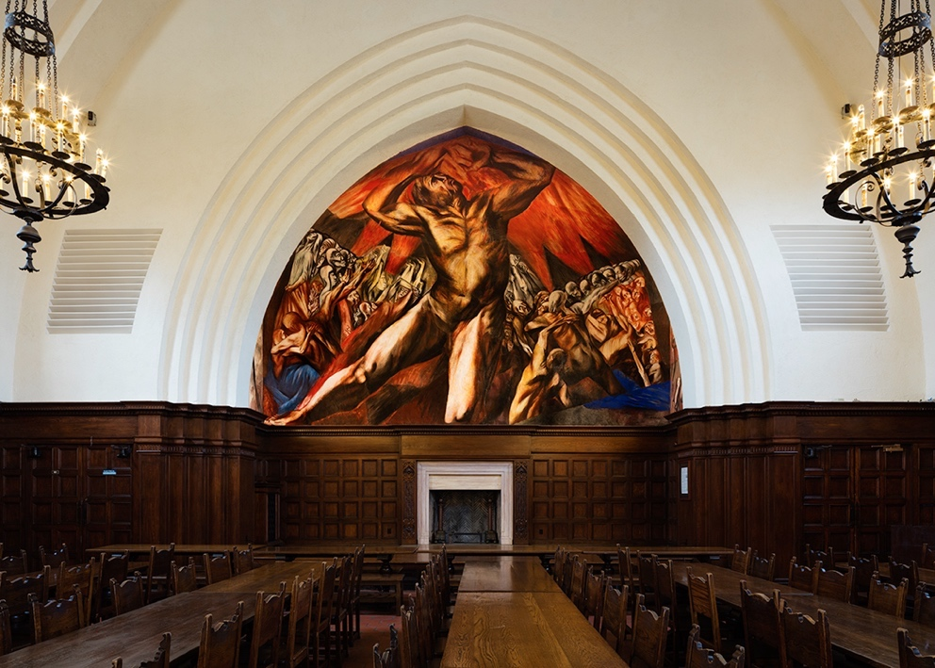
The first modern fresco mural to be painted in the U.S. by a Mexican artist was Orozco’s Prometheus. Prometheus, the hero who stole the divine fire from the gods and gave it to the human race for its liberation, is a recurring figure in Orozco’s work. Source: PCMA

Still, despite Orozco’s key role in the Mexican muralism movement, his work has a long history of being harmed by negligence. It took more than 20 years to save and protect Orozco’s murals in Veracruz after a 1973 earthquake; his frescoes at a Mexico City hospital are in poor condition, filthy and pulling away from the walls. In general, there is a lack of respect and recognition given to Orozco’s work in Mexico, by museums, artists and officials, alike (Cave).
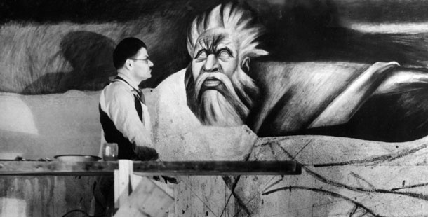
Orozco painting his Man of Fire mural in Guadalajara, Mexico. Source: Paradigm Productions/ITVS

Gregorio Luke, the former director of the Museum of Latin American Art in California, argues that “Orozco is one of our most important artists, not just in Mexico, but of the entire 20th century, and he has not been given the recognition he deserves. A lot of more scholarship needs to be done on Orozco. His works are more relevant than ever.”

David Alfaro Siqueiros
Siqueiros was not only the youngest of the Big Three muralists; he was also the one who brought his political ideas to the most radical plane (MMA). Siqueiros was born to a bourgeois family in Chihuahua, Mexico, on December 29, 1896, and because of this higher status he was allotted more opportunities starting at an early age (Velimirovíc). Siqueiros began to study visual arts and architecture at the Franco-English College in Mexico City in 1908, but his focus soon shifted with the onset of the Mexican Revolution in 1910.
A political activist and revolutionary since his youth, Siqueiros joined General Venustiano Carranza’s army at the age of 18, and later became a captain. While serving in the army, Siqueiros was exposed to the lives of many working and rural poor people, which he described in his manifesto, Vida Americana, and used as artistic inspiration for his later art. At the end of his military service, Siqueiros switched his focus to visual art because he believed artistic expression was something that could effectively blend with politics. He began to engage in the practice that would carry on throughout the rest of his life.
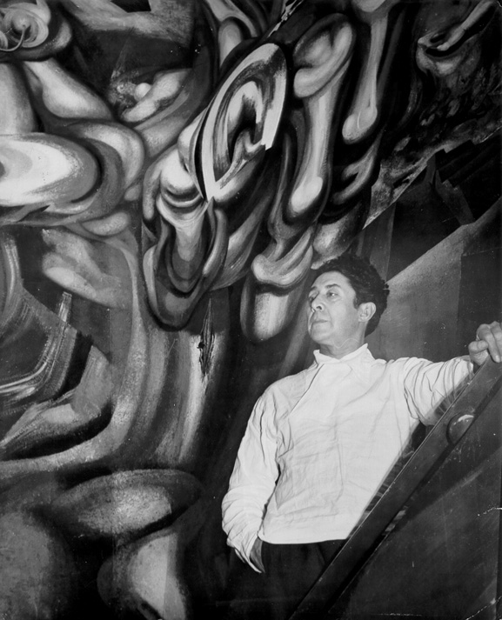
Siqueiros stands in front of his mural Cuauhtémoc contra el mito in Mexico City, 1944. Source: Acervo INBA-Sala de Arte Público Siqueiros

Siqueiros returned to Mexico City in 1922 and began participating in the muralism movement that same year. He first painted on the walls of the National Preparatory School of Mexico City, but he brought his distinct style and imagery to other areas of North America in the years that followed. Siqueiros developed a variety of pictorial materials, such as pyroxylin, a variant of acrylic paint, with which he painted a large body of work. He used encaustic – pigments mixed with hot wax – in some of his frescoes. His compositional technique, polyangularity, is another valuable contribution Siqueiros made that contemporary artists still rely on today (MMA).
In terms of his artistic style, Siqueiros never shied away from being bold. As Folgarait describes, the artist “supercharged his imagery with doses of political melodrama and warnings against any weakening in the face of bourgeois liberalism and the rising forces of international fascism” (5). Siqueiros melded his artistic and political backgrounds together through his murals, and used them as a medium through which to express his personal beliefs – beliefs that were primarily guided by Communist principles.

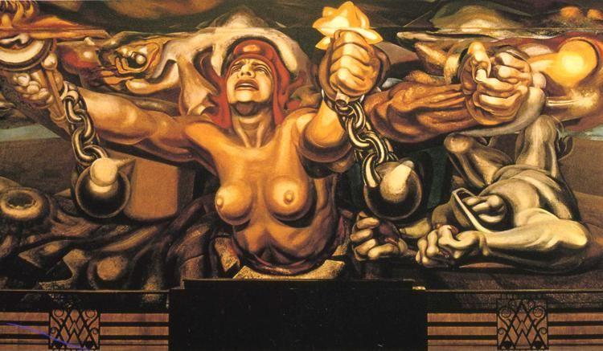
Siqueiros painted “New Democracy” (1945) to celebrate the victory over fascism at the end of WWII. Despite being heavily critiqued, this mural is still located on the second-floor gallery of the Palace of the Fine Arts, next to murals by Rivera and Orozco.

In the 1920s, Siqueiros became a member of the Communist party and was described in his New York Times obituary in 1974 as “a flamboyant and volatile Communist” who was even said to have had a hand in an attempt to assassinate Leon Trotsky later in life. In 1930, Siqueiros was arrested for organizing a Communist demonstration. After his release, he was unwilling to mute his political statements or abate his Communist activity and was therefore forced into exile in 1932 – first to the United States and then to South America. Still, Siqueiros was allowed to return to Mexico in the 1940s, and he began to work on a massive mural in Mexico City that occupied him until a few weeks before his death in 1974. Although his ideas were at times in opposition to the Mexican government, Siqueiros was officially recognized as one of Mexico’s patrimonial artists on July 18, 1980, and his work continues to be showcased in government buildings today (MMA).
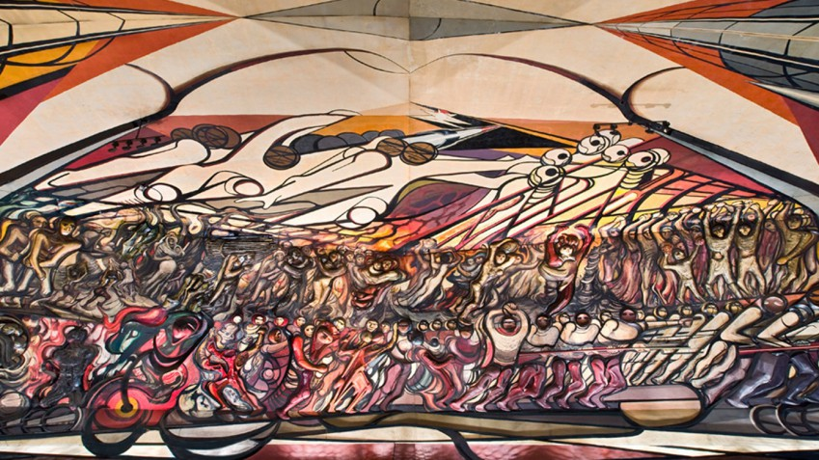
“The March of Humanity” (1971), Siqueiros’ largest work that took 10 years to complete cost about $1 million and covers the interior and exterior walls of a hexagonal Polyforum in Mexico City.

Legacy of Los Tres Grandes
Under the instruction of Vasconcelos, the artists Rivera, Orozco, and Siqueiros were given the opportunity to paint the first murals of the Mexican muralism movement. They were tasked with communicating Mexico’s history and culture using their own artistic visions and styles. But beyond that, they were responsible for shaping a new collective understanding of the Mexican people – at least, one that the government would support. This movement was not only a realistic and figurative movement, but one whose identity centered on the expression of public meanings (Greenberg).
In Art and Culture: Critical Essays, Clement Greenberg states, “The Mexican muralists’ principal objective was not pictorial innovation, associated with so much of twentieth-century Western painting. The muralists’ point of departure and primary concern was for a public and accessible visual dialogue with the Mexican people. As a public art, one of whose principal aims was to represent a notion of democratic cultural enfranchisement, the murals became a vital part of the patina of Mexican civic and national life for huge sections of the Mexican people.”
In Mexican Muralists: Orozco, Rivera, Siqueiros, Desmond Rochfort discusses the artistic era that came after the death of the final member of the original Mexican muralists: “When Siqueiros died in 1973, the story of Mexican mural painting did not end. A second generation of active and prolific muralist painters existed, such as Rufino Tamayo, Carlos Chávez Morado, Juan O’Gorman, Enrico Eppens, Jorge González Camarena and many others. Today, painters in Mexico continue to work on public commissions such as major projects in some of the subway stations of Mexico City” (218). Much has changed, of course, about Mexican mural art since the early days of the mural movement, but the work of Orozco, Rivera, and Siqueiros constituted a defining of the original aspirations and intentions of the Mexican muralist movement – one that lives on even today.

Chapter 6: Theoretical Functions of Urban Art
Up until this point, I have discussed some of the significant historical moments and figures that have defined Mexico’s past. Now, I will turn my focus to urban art itself through shifting from a historical framework to a more theory-based one. Then, in the following chapter, I will show some of these theories at-play in specific 20th-and-21st-century movements.
The Impact of Art
A significant body of research exists today that supports the visual arts for the various benefits they offer viewers. A recent study found that art had stabilizing effects on individuals in clinical settings by reducing distress, increasing self-reflection and self-awareness, altering behavior and thinking patterns, and normalizing heart rate, blood pressure, and even cortisol levels (Bolwerk et al). Art has also been shown to influence perceptions, like in the case of Frederick Douglass, who made himself the most photographed American of the 19th-century as a means of using his portraits to change the way viewers saw black people (Brooks). But what are the various functions urban art serves in social movements? And how might these differ from other forms of art that are not in the public domain?
By drawing from media theories, psychological studies, literary criticism, interviews, and my own experiences, I identified eight potential functions urban art can take on in the context of social movements. Depending on an artist’s intent for a piece and the way a viewer interprets it, these functions can vary in their impact. However, I believe that a case can be made that all urban art achieves at least one of these functions.
A Communication Channel
On the most fundamental level, urban art can act as a channel of communication – one that all people can engage in. Because of its visual as opposed to verbal nature, urban art is not reserved for people who speak a particular language or belong to an identity-based group. Rather, anyone can access urban art, though that access varies in degree. Social context is a key part of communication, as Michael Griffin explains in “Art as Communication.” Artistic production can be thought of as “both the communication of prevalent ideas in a particular culture at a specific point in history and, on a more micro-level, the result of the specific institutional and organizational contexts in which production processes, individual and collective, take place.” Through having a foundational understanding of the context surrounding a piece of art, viewers can engage in a richer conversation with it.
Additionally, art’s ability to influence viewers on an emotional level makes it a particularly effective channel for communication. When viewers feel affected on an emotional level, the messages they take in become more salient to them, and therefore more memorable. In other words, emotional experiences and the stimuli associated with them appear to be remembered vividly and accurately, with great resilience over time (Tyng et al).
A Source of Knowledge
If art is able to act as a generator of an unspoken dialogue, which I believe it is, art would naturally be able to help people acquire new forms of knowledge. In “Art, Knowledge and Testimony,” Iris Vidmar and Elvio Baccarini analyze visual art for its epistemological value, saying, “[Art’s] most peculiar and distinctive contribution is represented by its deepening of knowledge and a better understanding of the facts that we might already know, or in the shaping of our attitudes” (352).
They go on to say, “What art can do for us is not only provide us with facts, it can make us more aware of them, or of their relevance. Instead of giving us knowledge, or knowledge building propositions, it can make us become more sensitive towards something, it can raise our awareness about something, it can make us appreciate it better” (359). In making the viewer aware of certain topics and their relevance, art is influencing attitudes, which is connected to what I have identified as art’s third capability.
Attitude-Shaping
In the process of negotiation, audiences receive messages involving a range of factors including current and past media accounts, beliefs, knowledge and prior experience, structural barriers, and values. These may lead to attitudinal and ultimately behavioral commitment and change (Happer). McCaughan speaks to this same notion in Art and Social Movements, arguing that “the social power of activist artists emanates from their ability to provoke movement constituents and other publics to see, think, imagine, and even feel in meaningfully new ways” (6).

Individual Identity Affirmation
With new general attitudes come new attitudes regarding personal identity. How does art impact the way viewers understand their identities? Journalist and novelist Elena Poniatowska references the experience of Mexicans in the 1930s: “Upon seeing themselves reflected in murals, the people began to believe in themselves. It’s not that all the peasants in Mexico came to see the murals, it was that they sensed a respect for them that they had never felt before. And I believe it encouraged them. It nurtured them” (The Storm that Swept Mexico). In line with this perspective, urban art in Mexico has the potential to, on a basic level, affirm the existence of people and their individual identities. It also has the ability to help redefine notions of citizenship.
Collective Citizenship
Regarding new forms of citizenship, McCaughan argues that movement-affiliated artists “help to create visual languages and spaces through which people [can] imagine and perform new collective identities and new forms of meaningful citizenship” (1). In this way, the public works created by Los tres grandes were valuable for more than their aesthetic properties; they were a powerful tool that recognized the many people who had been previously marginalized and excluded in Mexico’s historical record. Los tres grandes, as well as more contemporary artists, have helped to bring underrepresented people back into the center of society through their more complex visual representations.

Cultural Testimony
Urban art also has the ability to function as cultural testimony, particularly during times of social unrest. In “Art, Knowledge and Testimony,” Vidmar and Baccarini explain, “At the most general level, we can regard some artworks as testimony because they include one person, namely the author, telling things to the other, his audience. In that sense, the most general account of testimony is satisfied… Epistemologists have long ago seen the importance of testimony in knowledge acquisition. In order to obtain knowledge of things not seen, experienced or tried, we have nothing else to rely on than the words of those who have seen it, experienced it or tried it. Given, of course, that they are sincere and competent, there is no reason to rule them out as unreliable” (355).
This excerpt challenges traditional understandings of urban art, likening it to more intellectually valued cultural objects such as testimony. This is an idea that has not been explicitly stated in any of the prior research I have come across, but I argue that it warrants that categorization. When done effectively, urban art that acts as true cultural testimony can even be a contributing factor to social mobilization.
Social Mobilizer
Alicia Azuela, author of “Public Art, Meyer Schapiro and Mexican Muralism,” believes in art’s power to mobilize the masses: “The practical meaning of militant art should be judged with recourse to its positive effects within the social movement that generates it. For this reason, the work of the Mexican muralists, when freed from party judgements and placed in the context of the social movements that conceived it, and owing to its expression of a sincere hatred of oppression and a fundamental sympathy towards the masses, has achieved its ultimate end by serving as a constant stimulus to mobilize on behalf of change” (59).
Azuela continues, “This remains a possibility, because the artist who is identified with the popular struggle and who finds his principle [sic] source of inspiration in the people’s lives along with their struggle, contributes to the acquisition of greater class-consciousness and also to the building of faith in that struggle” (59). In the following chapter, you can see this concept of art as a mobilizer contextualized within specific movements across Mexico.
Preserver of the “Unofficial” Story
In We Are the Face of Oaxaca, Lynn Stephen argues that some of the icons depicted in urban art can become vehicles for a collective cultural memory and for the commemoration of key events, like in the case of art in Oaxaca in 2006. This can be used to combat the often-untrue hegemonic historical narrative that governments and other entities of power promote. Urban art enables more people to legitimately communicate in public spaces and construct a shared social memory that can live on far into the future.
Summary
Urban art can operate as a channel of communication in that it provides a space for ideas to be exchanged that can lead to the acquisition of new forms of knowledge. New knowledge can lead to new attitudes, as well as to new understandings of the self. Urban art can help to affirm individual identity, in the way that it represents everyday people and gives them a voice. It also constructs new ideas of citizenship, when community members begin to reflect on how their individual identities fit into the collective whole. In some cases, urban art can actually act as cultural testimony, through promoting a narrative that may run contrary to the hegemonic, government-imposed one. This, when effective, can inspire social mobilization. Urban art can be used to preserve cultural memory through representing and disseminating the sometimes-unofficial versions of “what really happened.”

Chapter 7: Urban Art in 20th- and 21st-Century Social Movements
In this chapter, I will be looking at three major movements that have occurred in Mexico within the past 70 years – the Student Movement of 1968, the Oaxaca Teachers’ Strikes of 2006 and the Ayotzinapa Movement of 2014 – and drawing connections to the theories outlined in the previous chapter. Because Mexico has been a site of multiple social movements in the last century, I had to be selective in which ones I chose to analyze. I believe that in each of these three moments from Mexico’s recent history, urban art played a key role in elevating individual community members’ voices, empowering people to mobilize, and challenging state-enforced narratives. This was especially significant, because the accounts of these social movements given by Mexican officials after the fact have largely been cynical fabrications (Figueroa).
Looking at general trends in Mexico’s history, in the early 1930s revolutionary gains were consolidated, and the process of institutionalizing the Mexican Revolution moved forward. By the 1940s, the Institutional Revolutionary Party (PRI), a single dominant political party, emerged and held uninterrupted power through 2000 with little competition (Ganster,132). As the years went by, the promises of the 1917 Constitution began to fall by the wayside, and people sought radical change for themselves once again.
The Student Movement of 1968
By the late 1960s, people across Mexico had grown increasingly dissatisfied with the regime of the PRI and its use of riot police to counter gang violence among youth. Their discontent boiled over in 1968, a year when people around the world demanded deeper processes of democratization, unbridled freedoms, local autonomy, and community empowerment. McCaughan explains what this social context meant for Mexico in Art and Social Movements: Cultural Politics in Mexico and Aztlán, saying, “At a different historical moment, what began as a series of student protests against bus fares and scuffles between rival student gangs might never have grown into a mass movement capable of mobilizing hundreds of thousands of protesters” (7). However, it just so happened to be an apt moment for people seeking change to mobilize in action.
Mexico had been selected to host the 1968 Olympic Games, making it the first Latin American country and the first developing nation to host the event. “Many had questioned if Mexico had sufficient funds, knowledge and organizational skills to meet the demands of such an event,” recounts Claire Brewster in “The Student Movement of 1968 and the Mexican Press.” The patron of the Games, President Díaz Ordaz, countered this criticism by using the occasion as a showcase for Mexican stability and progress (171). His administration committed to constructing everything needed for the Olympics, which totaled a massive cost of $150 million, or $1 billion today. When they learned about Ordaz’s agenda, thousands of high school and college students began to speak out against the money that would be “wasted on a facade,” and the protests quickly escalated into a full-blown movement (The Storm That Swept Mexico).
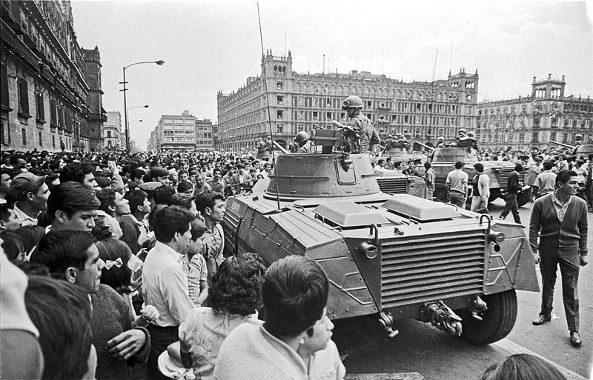
Protesters gathered in the Zócalo on August 2, 1968. Source: Unknown

According to protesters interviewed in The Storm That Swept Mexico, the students believed that in their set-up for the Games, the government was hiding the real Mexico – the “Mexico of misery,” the Mexico of political prisoners, the Mexico of human rights violations. Protesters issued a series of demands, from an end to the riot police, to the liberation of political prisoners, to improved conditions for laborers. More than 300,000 people marched through the Paseo de la Reforma to draw attention to these demands. Students at the nation’s two leading art academies, San Carlos and La Esmeralda, produced hundreds of posters, flyers, and banners, and used bold graphics to express their discontent. Still, all of this was merely buildup to the main event that took place on October 2, 1968.
Ten days before the start of the Olympics, approximately 10,000 people gathered in a residential area called Tlatelolco to peacefully protest their nation’s one-party government and lack of political freedom. While listening to students speak out on the esplanade of the Plaza de las Tres Culturas, participants watched as flares suddenly appeared in the sky overhead; then the first shots were heard. Without warning, the police and the military shot and bayoneted to death an estimated 325 unarmed Mexican youths in a period of gunfire that lasted for 29 minutes. (Poniatowska, 203). One witness remembers, “It looked like a battlefield. Women’s and men’s shoes scattered all over. You could see bullet holes in the walls and lots of broken windows. It was a true military takeover of the Plaza de las Tres Culturas” (The Storm That Swept Mexico).
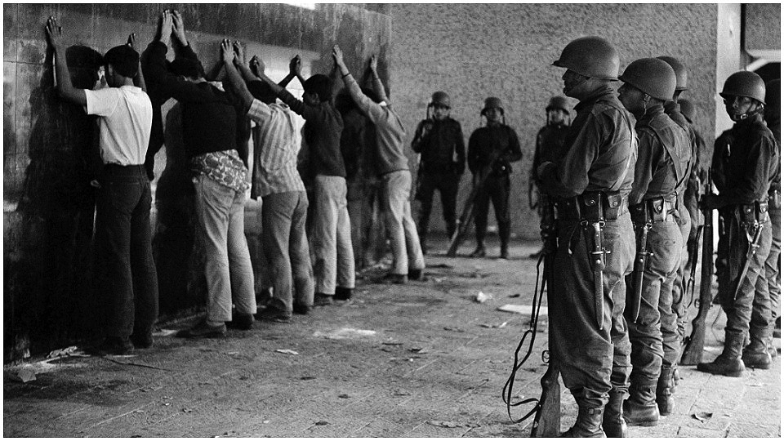
Mexican army troops hold a group of young men arrested in the Plaza of the Three Cultures district in Mexico City on Oct. 3, 1968. Source: AP

While hundreds of people lost their lives, many other protesters were imprisoned, forced underground, or exiled. At the time, the Mexican government and media claimed that protesters initiated the fighting, but government documents have called that version of events into question, even suggesting that snipers were employed by the government before any civilian violence broke out. This event rocked Mexico and showed just how far the government was willing to go to shut down dissidents. At the same time, it also encouraged people who had witnessed the event for themselves to share the unofficial story of what had happened, much to the chagrin of the Mexican government.
According to a 1968 story in La Prensa, no photographs of the dead bodies lying in the Plaza de las Tres Culturas were taken because the Army troops would not allow it. The story of what happened at Tlatelolco “is puzzling and full of contradictions, but the one fact that is certain is that many died. Not one of the accounts provides an overall picture of what happened” (Poniatowska, 208). In the aftermath of the Tlatelolco Massacre, some prominent artists emerged with one clear objective: to ensure the events of 1968 were remembered for what they really were.
Arnulfo Aquino and Jorge Pérez Vega are two artists who played a critical role in this process by preserving the art of the movement itself. In her El Universal article “Centinelas de la Memoria, México 68,” reporter Adriana Malvido describes Aquino and Vega as operating with the belief that images exercise incomparable power in determining what we remember. That belief is what compelled them to collaborate with the group Mira starting in 1973, and together, they located and archived more than 200 prints that came out during and after the massacre.
These 200 prints have since been published in multiple iterations of La gráfica del 68, Homenaje al Movimiento Estudiantil, Aquino’s and Vega’s image-based book that keep the images of 1968 alive for viewers today. These preserved works are valuable for the way that they help cement a counter hegemonic narrative in the mind of the public and affect consciousness long-term. This is especially true in the case of a few iconic images that can still be seen on the streets of Mexico City 50 years later.
One example is Adolfo Mexiac’s “Freedom of Expression,” a poster that directly plays on the false narrative that was spun for the Olympics. In this poster, Mexico’s logo for the Summer Olympics of 1968, a clean contemporary design, appears underneath the words “¡LIBERTAD DE EXPRESIÓN!” and Mexiac’s social realist engraving from an earlier era: the face of a man whose mouth has been chained and padlocked (McCaughan, 21). Generally, artists before 1968 avoided publicly critiquing the Mexican government, but this marked a clear shift in opening up new forms of protest that artists could participate in.

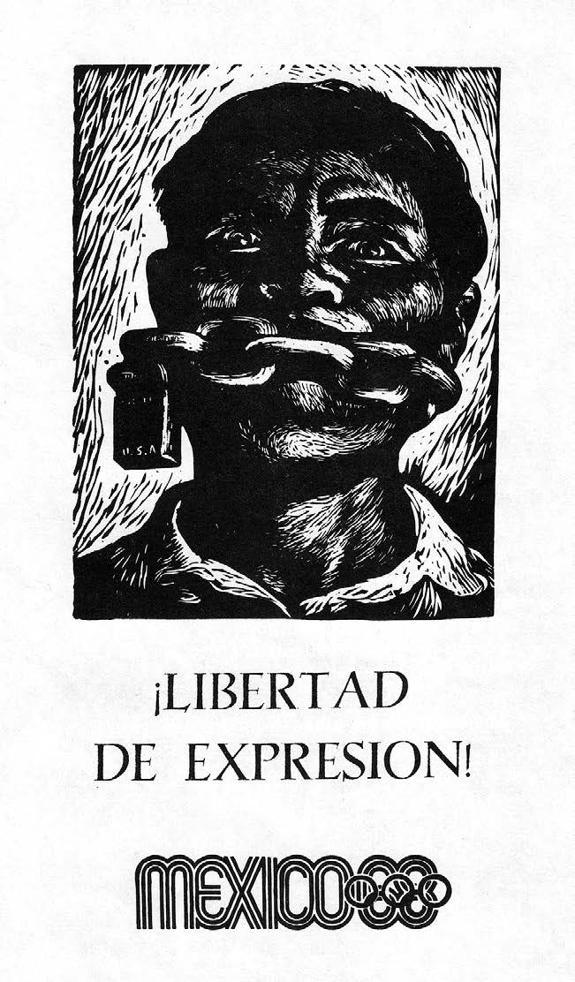
Adolfo Mexiac’s ¡Libertad de expresión! 1968 poster. Source: Grupo Mira (1988)

Another shift that occurred in the aftermath of the Tlatelolco Massacre was the reevaluation of the meaning associated with national symbols. As McCaughan describes, “In a move quite startling for its boldness at the time, student movement artists frequently used the iconic eagle and snake as symbols of repression. Take, for example, the menacing image engraved on a movement poster in 1968: then President Gustavo Díaz Ordaz appears as a bayonet-winged eagle hovering over a snake that seems to speak the president’s words: ‘AQUI NO MAS MI CHICHARRON TRUENA’ (‘my voice is the only one heard here’)” (25).
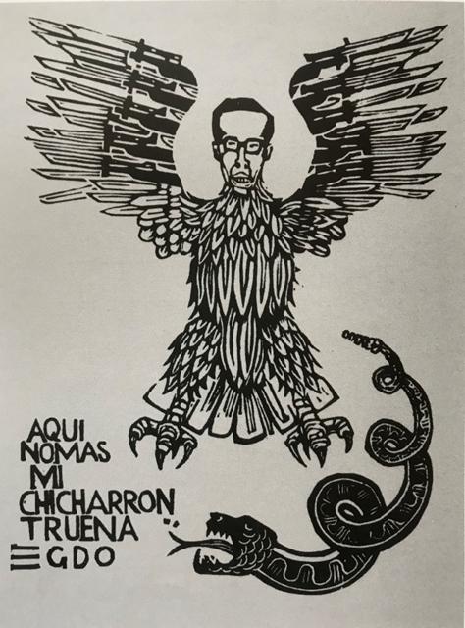
Anonymous La Esmeralda Art Academy student, 1968.

The symbol of the eagle and snake – which today can be seen on Mexico’s coat of arms – originated in Aztec legend, according to which a god named Huitzilopochtli appeared to a nomadic tribe leader in his dream and gave instructions to settle wherever the tribe found an eagle perched on a cactus, devouring a snake. The land they selected was Tenochtitlan, present-day Mexico City, and the eagle and snake represented these origins. However, the events of 1968 led some artists to work to challenge the connotations of dominant national symbols.
McCaughan explains, “Such images were seen repeatedly by hundreds of thousands of Mexicans between July and October of that year. They were carried on protest marches, pasted on the sides of buses, draped from public buildings, and circulated on flyers in market places throughout the capital. They worked to unmask the hegemonic regime by unfixing the meanings attributed to these symbols by the regime’s political and cultural agents” (26). They also helped to spur a youth movement that is still very much alive today.
After the events of 1968, “a generation of youth was politicized by the student movement and went on to lead a diverse array of social movements, community organizations, and opposition political parties in the 1970s and 1980s that helped advance Mexico’s still halting democratic transition” (McCaughan, 7). Many of the artists involved in or influenced by the student movement continued their activism work by forming political art collectives that used visual art to advocate for other popular movements. They focused attention on a variety of social issues, from poverty, repression, corruption, environmental degradation, and U.S. relations, expressing these concerns in a visual language that can still be observed today.

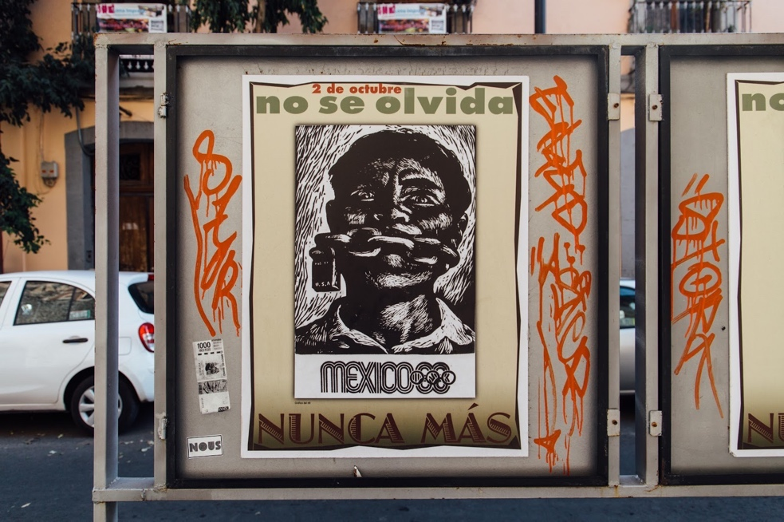
I came across Mexiac’s reprinted 1968 poster while in Mexico City’s center in February 2019.

The Tlatelolco Massacre was not an isolated incident. It emerged out of a collective fight for rights and democracy, with roots stretching from the past into the future. As Poniatowska said a few years after the Student Movement of 1968, “The wound is still fresh, and Mexicans, though stunned by this cruel blow, are beginning to ask themselves questions in open-mouthed amazement. The blood of hundreds of students, of men, women, children, soldiers, and oldsters tracked all over Tlatelolco has dried now. It has sunk once again into the quiet earth. Later, flowers will bloom among the ruins and the tombs” (Poniatowska, 208).
Oaxaca Teachers’ Strikes of 2006
In the years that followed, Mexicans continued to ask questions, and flowers continued to bloom, wilt, and bloom again. In 2006, Mexico witnessed another movement – this time in Oaxaca. Oaxacan way of life was disrupted by a six-month interruption of the state government, which emerged out of growing discontent and polarization within greater Oaxaca. The state was embroiled in the largest teachers’ protests in recent history, and the violence that ensued left 30 people dead. It also resulted in new forms of protest and notions of citizenship.
In 2004, Ulises Ruiz Ortiz became the Governor of Oaxaca as a member of PRI in an election he was rumored to have rigged. Ortiz did not waste any time in making clear his stance toward those who criticized his government; on his first day in office he approved the takeover of the offices of the Oaxaca newspaper Noticias, and began censoring the press, as well as harassing and repressing the leaders of a wide range of organizations. By June 2006, a large segment of Oaxacan society disliked Ortiz and his government (Stephen, 75).
As University of Oregon professor Lynn Stephen explains in We Are the Face of Oaxaca, in May 2006 a large group of teachers who belonged to Sección 22 (Local 22) of the National Union of Educational Workers and were part of an independent movement within the larger national union engaged in their annual sit-in, where they tried to negotiate higher salaries for themselves and better conditions for school children. Ortiz did not accept their demands, and after the teachers dug in more, the governor sent in state police to remove the teachers from their occupation. In this process, the police tear-gassed and wounded some innocent bystanders, which only served to increase the tension running throughout the city (Stephen, 6).
Through taking advantage of general civic discontent, the teachers formed alliances with other organizations whose leaders were also waiting for an opportunity to gain a broader audience. The teachers and the new alliance of radical organizations known as APPO – the Spanish acronym for the Popular Assembly of Oaxaca – called for the governor’s resignation; when Ortiz refused, APPO took radical action. Their strategies included mega-marches, the occupation of state and federal buildings and offices, the takeover of the state’s television and radio stations, the construction of barricades in many neighborhoods, regional movements throughout the state, the construction of a parallel police force, and the creation of a constitution and state assembly structure geared toward a more inclusive and participatory political vision (Stephen, 95).
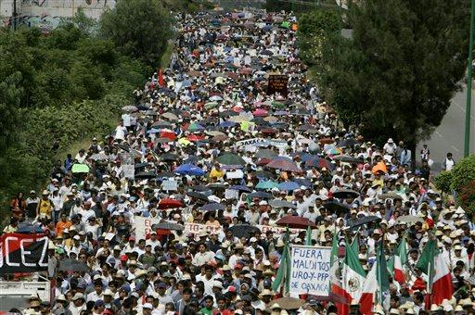
Supporters of the Popular Assembly of Oaxaca (APPO) march on the highways in Oaxaca, Mexico, Sunday, Nov. 5, 2006, demanding the resignation of Oaxaca Gov. Ulises Ruiz. Source: Eduardo Verdugo of AP

Throughout this period, appeals were made to the federal government to intervene and help calm down the escalating conflict. After the death of an American journalist in October 2006, it became necessary for the federal government to find a solution. As the “official” story goes, Ortiz sent in the Preventative Police who restored order and security in the city. However, Stephen believes that it is the people who participated in and were strongly affected by the 2006 social movement that know the true story.
In We Are the Face of Oaxaca, Stephen looks at the 2006 movement from the perspective of some of the many Oaxaqueños who experienced it and regards oral testimony as a key tool for challenging hegemonic narratives and producing a historical record. Stephen defines testimony as referring to a personal account of an event or experience as delivered from the lips of a person through a speech act, calling it “an oral telling of a person’s perception of an event” that signifies witnessing. She sees it as synonymous with rights claiming, in how it permits silenced groups to speak and to be heard, to enact alternative visions for political and cultural participation, and to formulate new, hybrid forms of identity (2).
At the same time that oral testimony emerged as a form of radical participation, so, too, did urban art. This movement gave all people – the young, the old, the indigenous, the disenfranchised – a new opportunity to engage in the social dialogue of the times and assist in the efforts against the state. In 2006, graphic art, which was predominantly created through the use of stencils, started to populate Oaxaca’s city center, becoming a powerful participatory tool. Stephen describes the walls in downtown as “public galleries for a distinctive genre” and the tagged occupied government buildings as “belonging to the social movement” (256). Much of this art has been specifically categorized as public popular art (arte pa’i pueblo), and it has become part of the formal art market in subsequent years, mainstream in terms of culture and essential in terms of economy.
While many individual artists operated during the 2006 movement, it was a time in which colectivos – artist collectives – formed to spread their messages with greater speed and visibility. ASARO, which stands for the Assembly of Revolutionary Artists of Oaxaca, and Lapiztola (the pen as pistol) are two of the most prominent collectives, and they still produce work today. Guillermo Pacheco, one of the artists in ASARO, described the collective to Stephen in the following way: “ASARO was organized as a part of the different levels that the social movement of Oaxaca has. We are an assembly of artists who are unified by the goal of liberty in expression. We denounce the problems in a broken system. Our objective is to propose an alternative counterculture to the one that has been planted in Oaxaca, with a central focus on graphics” (261).
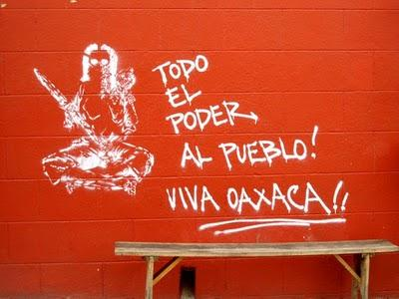
“All the power to the people, long live Oaxaca!” reads ASARO member Beta’s piece from 2006. Source: Itandehui Franco Ortiz

In pairing the image of an armed calavera woman with a child slung on her back with the slogan “All the power to the people,” Beta is recognizing and validating “the people” as a public political identity – a function of urban art I outlined in the previous chapter. Wons and Line, two other members of ASARO, also created art that Oaxaqueños could identify with, the most notable of which was La Virgen de las Barrikadas.
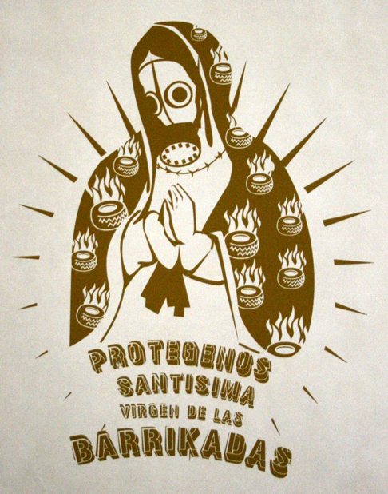
La Virgen de las Barrikadas, by Wons and Line of ASARO. Source: Unknown

La Virgen de las Barrikadas (The Virgin of the Barricades) is a virgin modeled after the Virgen de Guadalupe, wearing a gas mask and a cloak covered in burning tires. The logo reads “Protect us Holy Virgin of the Barricades” and deliberately misspells barricades, provoking the theme of resistance that is reflected overall in the image. Wons’ and Line’s Virgin was adopted by teachers in Sección 22 and other parts of APPO, who incorporated the image on banners in marches (Stephen, 271). This shows, once again, that urban art has the potential to transform two-dimensional art into a cultural symbol – one that brings people together in times of division.
With this context established, I want to return to the topic of testimony, primarily to say that while I agree with Stephen’s argument that oral testimony was a key factor in the movement of 2006, I want to posit that urban art can act as testimony as well. As the art left behind from this movement shows, protest imagery and icons have become vehicles for the social memory and commemoration of key events of 2006. Testimony gives witnesses the chance to “be there and to experience the reactivation of past events by making them present once again” (Stephen, 28), and so, too, does urban art. Both oral and visual testimony can keep the past alive and influence cultural and political landscapes, as in the case of Oaxaca in 2006.
Overall, the legacy of the Oaxaca Teacher’s Movement is a bittersweet one. At least 23 people lost their lives that year, hundreds more were arrested and imprisoned, and more than 1,200 total complaints were filed with human rights commissions. Oaxaca experienced a severe decrease in tourism, ushering in years of recessions that put their artisans, laborers, and everyday people on the brink of poverty. But just as it brought challenges to Oaxaca, this movement also brought opportunity.
In recent years, Oaxaca has seen a dramatic increase in talleres – graphic art galleries – which I will speak to in the following chapter. Urban art is becoming an increasingly important part of the Oaxacan economic system. Yet with the growing popularizing of Oaxacan art comes tension between the creation of art as a political statement and a source of income. In the next chapter, I will look more closely at this dynamic, but before doing so, I will finish this discussion of 20th- and 21st-century social movements with a brief summary and analysis of the Ayotzinapa Movement of 2014.
Ayotzinapa Movement of 2014
The third and final movement I will touch on in this thesis – arguably the most notorious in Mexico’s recent history – was the disappearance of 43 students in 2014. On the evening of September 26, about 100 students gathered in the outskirts of Iguala, Mexico planning to travel to a demonstration related to commemorating the Tlatelolco Massacre from decades earlier. At the time, they were studying at Ayotzinapa, a rural teachers’ college located in the state of Guerrero, a place that is known for its activism (Carlsen). Vice News provides a clear timeline of the events of the 26th that began after nightfall when the Ayotzinapa students entered the city of Iguala, about 90 miles away from their campus. They had traveled in two buses and picked up a third along the way, intending to commandeer more buses to take to Mexico City. At around 9:30 p.m., the students left Iguala in five buses, planning to return to Ayotzinapa. 43 of them never made it back.
The first documented call to an emergency dispatch number was received at 9:48 p.m., when several police cars full of officers intercepted the students and began shooting at them. The buses were attacked on different occasions about two hours apart. In the first attack, student Aldo Gutíerrez was shot in the head by police, and officers shot at those who tried to go to his aid. The first attack ended with police detaining students from one of the buses and driving them away in police vehicles, while the second attack took place after other students arrived at the scene to provide support. By the time local news reporters arrives, multiple students had already been killed, while in another part of the city, an entire busload of students was detained.
In the days that followed, survivors of the attacks and others attempted to locate the missing students by going to jails and police stations. They found no trace of their missing classmates, who totaled 43 in the final count and have still not been found at the time of this writing. Julio César Mondragón was one of the students who was confirmed dead shortly after the night of the attack. He had fled when the shooting began and had become separated from the group. When Mondragón was found, his facial skin and muscles had been torn away from his head, his skull was fractured in several places, and his internal organs were ruptured. According to investigators, his condition “shows the level of atrocities committed that night.” (Semple).
On September 28, the Guerrero state authorities arrested 22 Iguala municipal police officers in connection with the attacks; they had allegedly been working with the Guerreros Unidos cartel. Then, on October 4, state authorities announced that they had located mass graves in the hills just outside of Iguala that could potentially hold the remains of the missing students. Authorities initially declared that 28 bodies were found there, a figure that eventually rose to 38. However, a week later, it was announced that at least some of the bodies discovered in the first set of mass graves did not belong to the missing students, drawing attention to the fact that clandestine burial sites linked to drug-war violence can be found throughout Guerrero (Vice).
Within a few months of the attack, journalist Anabel Hernández began investigating what had happened, later publishing her findings in La Verdadera Noche de Iguala (The True Night of Iguala). Her findings showed that while the government denied knowing anything about the attack and the students’ disappearance, the federal authorities had really been monitoring the students for four hours before it happened. As Hernandez states, “The drug cartel, the army, intelligence services and the federal police all contributed to what happened that night, and then did everything they could to cover it up” (Deslandes).
This event did more than draw attention to state corruption in Guerrero. It also encouraged people to seek change through the political system: “The Ayotzinapa case became a flashpoint for last year’s federal election,” says Ann Deslandes in her article for The Guardian. “Millions switched their votes from the long-standing dictatorial Party of the Institutional Revolution to Andrés Manuel López Obrador’s populist Morena party on the promise that this emblematic case of the violent and unaccountable conflict that plagues Mexico might be resolved, making way for a new dawn of peace, transparency and the rule of law” (Deslandes). In January 2019, President Andrés Manuel López Obrador created a truth commission to re-investigate the case, but little progress has been made so far, leaving people waiting for answers that may never come.
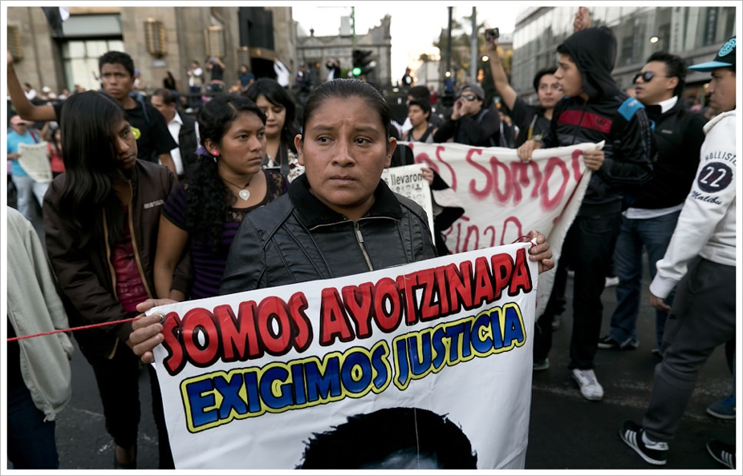
“We are Ayotzinapa. We demand justice.” Source: Flickr user Montecruz Foto

Urban artists have played an important role in the aftermath of the disappearance of the Ayotzinapa students. Through creating public works, some of which are located in the center of Mexico City, they keep this massacre at the top of the public’s conscience and constantly challenge the Mexican government to find answers. Many of the public works made since 2014 feature the number 43 and use different imagery to portray the government as the perpetrator of violence and the people as the victims of it, as exemplified in a 2015 mural by Italian artists Ericailcane. This mural shows a menacing jaguar baring its teeth at a group of rabbits, one of who wears an armband with the number 43.
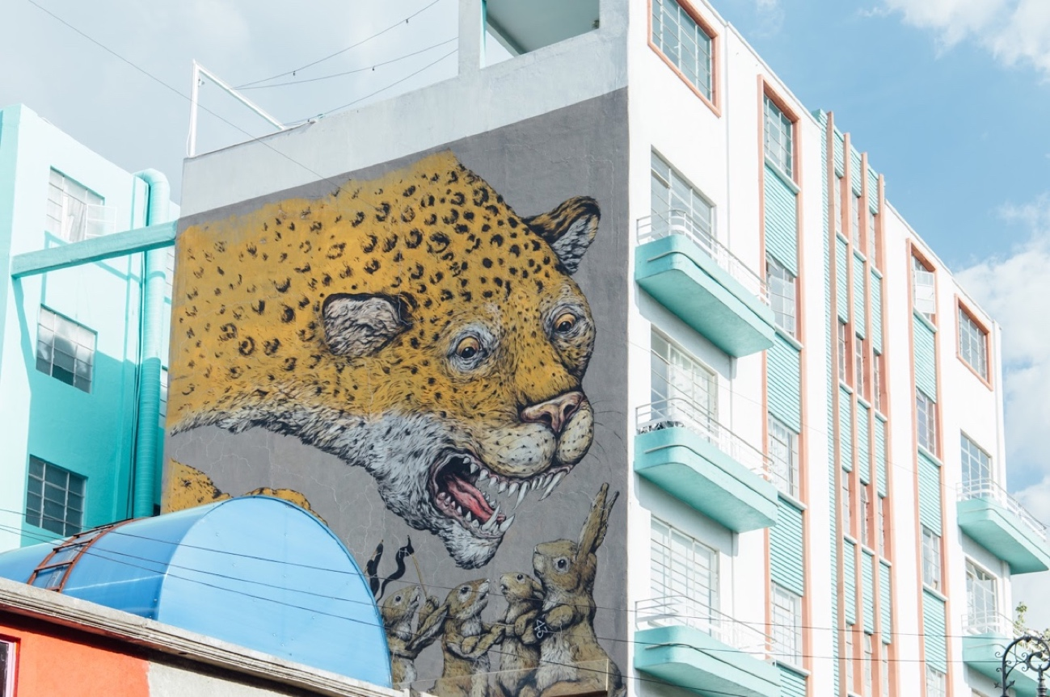
Ericailcane’s mural is located in an area frequently visited by residents and tourists alike, drawing awareness to the events of 2014.

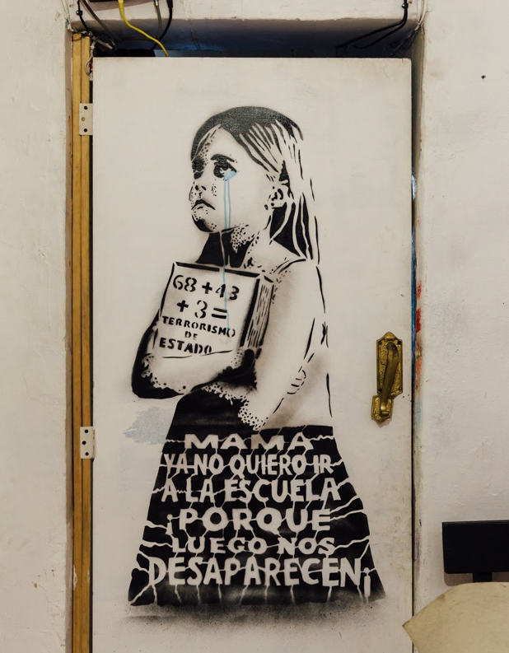
Yescka created this image through spraying aerosol paint over a handmade stencil. It highlights the danger of state-organized disappearance that even young students face.

In Lapiztola’s El abrazo ausente, a mother still waits for news of her son who vanished during the violence of the late 1960s and 1970s, hugging a silhouette composed of doves. The piece has contemporary resonance and is a powerful visualization of the cycles of loss that Mexico has endured in the last fifty years. “It was bad enough for the mothers of the students who were killed, but I think it’s worse for the mothers of those who were disappeared; their suffering is unending,” remarked Vega, one of the members of Lapiztola (Jones).

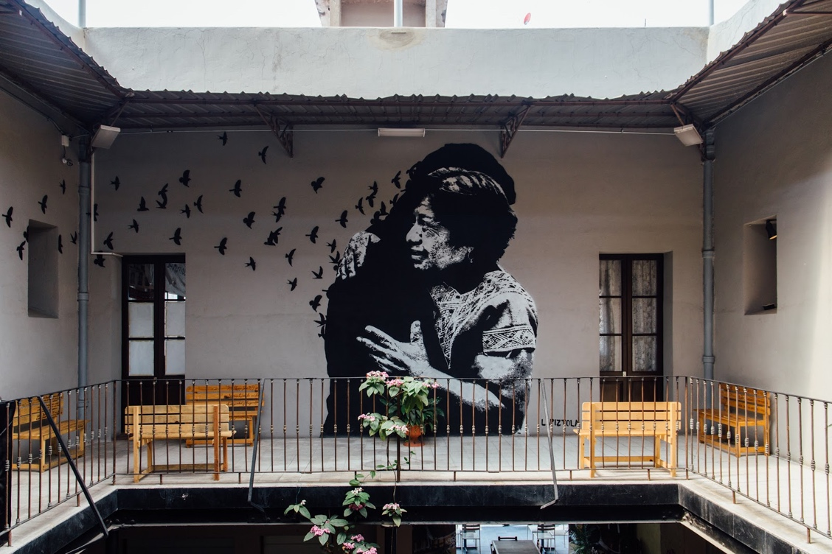
Lapiztola’s mural connects to both the events of the 1960s/70s and 2014.

The Student Movement of 1968, the Oaxaca Teachers’ Strikes of 2006, and the Ayotzinapa Movement of 2014 all occurred in different social contexts, but they converge in the way that urban art was at the center of each of these movements, acting as a visual form of cultural testimony. But what role does art play today? And how does it function differently in Oaxaca and Mexico City? That is what I will address in the next two chapters.

Chapter 8: Oaxaca Today
Urban art played a key role in the popular movement that engulfed Oaxaca in 2006, but I had only the faintest idea that this was the case when I first saw the state for myself in 2017. Although I found myself walking the same streets that had witnessed mass-movements a mere 11 years earlier, I struggled to imagine what it had been like before, when families occupied barricades and fought for basic human rights. For this reason, I sought out the perspectives of people who experienced this transformation firsthand – an element that I believe is essential to my research. What follows is a more personal look into the culture of Oaxaca’s contemporary urban art community, which has been largely informed through the interviews I have conducted and the on-the-grounds experiences I have had since 2017.
Setting the Scene
One of the things I have come to look forward to most when visiting Oaxaca is the drive from the airport into the heart of the city. Pressed up against the glass of my group taxi van window, I watch the landscape change, from rural to urban, muted to vibrant. Stray dogs bask in the hot sun, and trucks race by, their cargo beds filled with men packed shoulder-to-shoulder and knee-to-knee. In a matter of minutes, the first mural comes into view, and from there, it becomes a steady visual stream. I was just as mesmerized my second time on this ride in December 2018 as I had been nearly two years earlier, only this time I felt myself searching the walls for art I remembered from before – for my old friends.
Avenida Símbolos Patrios brings you into the city center, and only there does the presence of urban art start to drop off. Deemed a UNESCO heritage site, the historic center of Oaxaca boasts strict laws against the placement of urban art on its many buildings that are hundreds of years old, hindering some artists from leaving their own marks on the historic walls, while inadvertently compelling more rebellious artists to do just that.
Legality of Urban Art in Oaxaca
As a member of ASARO during the 2006 Teacher’s Movement and a long-time photographer of Oaxacan urban art, Itandehui Franco Ortiz is more than familiar with the laws governing art in public spaces. In a 2017 interview, she told me, “Oaxaca is a heritage site and in general, it isn’t legal to paint in these kinds of cities. When I would go to other cities, for example, Guanajuato, friends would ask, ‘Is it true that the city center is painted, but the city is ‘patrimonial’? Why [does the government] let them paint?’ And I would say, ‘They don’t let them. People just go and do graffiti. It won’t turn out good for you.’”
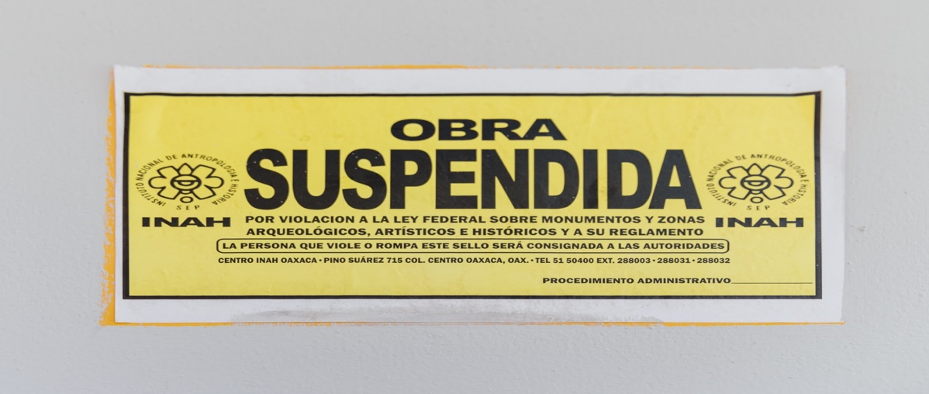
Translated, this sign reads, “Work suspended for violating the federal law on monuments and archaeological, artistic and historical areas and their regulations. The person who violates or breaks this code will be consigned to the authorities.”

Ortiz provides a more specific explanation of these laws in the thesis she wrote for the National School of Anthropology and History, identifying two types of graffiti and the ways they function. These two types are illegal and legal, and they are mainly distinguished by the manner in which they take up space. Illegal graffiti “exerts a transgressive power over the public space, by appropriating spaces without prior consent” – that is, taking the desired wall despite the property owner’s refusal (108). Most street artists start on the illegal side; however, others choose the legal route, meaning they get explicit permission from the home or business owner whose wall they choose to paint on.
There are multiple reasons some artists prefer doing legal graffiti. For example, they may want to avoid fines or temporary arrest because they could live a lifestyle that does not allow them to risk being arrested by police; or they might have acquired an affinity in doing detailed work over a longer span of time than illegal graffiti allows for (108). In recent years, realism has become a somewhat desirable style of urban art that people have become increasingly willing to invest in for their homes and businesses. With that shift, more and more artists are forced to change up their styles to meet consumer demand, or risk not getting permission for a space they want to paint. This can result in a de-politicization of urban art, as artists are painting to appeal to their particular audience (108).
Katalina Manzano is another artist who I interviewed in Oaxaca. Although she has only been painting murals for a year, Manzano is already familiar with the challenges surrounding painting in Oaxaca’s city center, as well as the opportunities: “It can create a dialogue with the municipality. There is the chance to create this dialogue. That would be important, but it is complicated.”
Legacy of the 2006 Movement
Though there are certain restrictions today in terms of where and what artists can paint, many artists in Oaxaca remember the even greater challenges they faced before the 2006 movement. In a 2017 interview, Ortiz told me about the challenges she faced in trying to paint in the city center:
When the movement started, it was really difficult for you to get permission to paint in the streets. It was really hard to get the materials to paint. There were a few that started doing political art because at that time the Zapatista movement started again, so there was an identification with a few graffiti artists who started painting with pride and dignity with respect to indigenous blood. It started then. 2006 was more of a politicization of messages. People started painting their politics – people who did not have much to do with art or graffiti, but they still did it. It was around 2006 that they painted a lot with those themes in a more honest way of what was actually happening. Things were changing.

In February 2019, I had the opportunity to interview artist Yescka who was not only a member of ASARO during the movement, but one of its founding members. Yescka was involved in the opening of Espacio Zapata, ASARO’s gallery, in 2009, but today he has his own space named Studio Siqueiros. He had this to say about the lasting impact of the 2006 movement:

2006 helped me discover and evolve. Art has a lot of power. Art is a way of communication. I think if [the movement] wouldn’t have happened in Oaxaca in 2006 perhaps I would be an irresponsible artist that would be finding a way to sell my art, or position myself as an artist. It changed my perception. It gave me a societal education, political too. I think I became a more aware person. This helped me a lot to choose my path. If 2006 wouldn’t have existed, maybe I wouldn’t have a studio, maybe I wouldn’t have a space. Maybe I would have been working on something else or finding a gallery to accept my work. I think this movement also gave me some knowledge and liberty to defend my own stuff. I learned to defend my own thoughts, the form I see things, and my art. It made me a strong person in that sense.

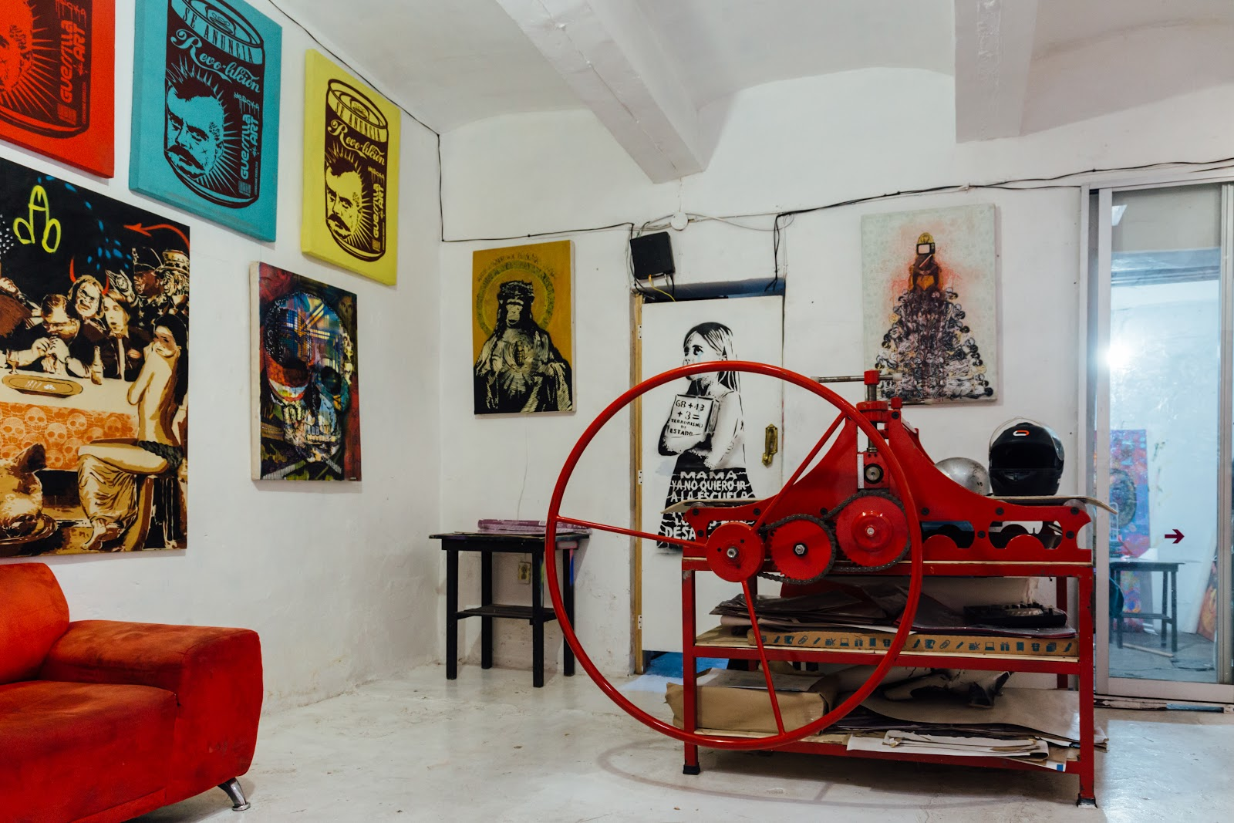
Inside Taller y Galería Siqueiros, Yescka’s studio in Oaxaca.

The Emergence of Talleres
The presence of talleres in Oaxaca’s city center surged in the years following the Teachers Movement, as people around the world learned about Oaxaca’s artisanal goods and traveled great distances to purchase them. Some of the city’s graphic artists capitalized on this trend by creating a Graphic Passport. As inscribed on the paper map, the passport is intended to “promote independent spaces in order to make public the ongoing work of graphic arts studios in the city of Oaxaca and their different techniques.” At each of the 12 gallery locations, visitors can receive a personalized stamp, and once they have collected all of the stamps, they can purchase art at a discounted rate.
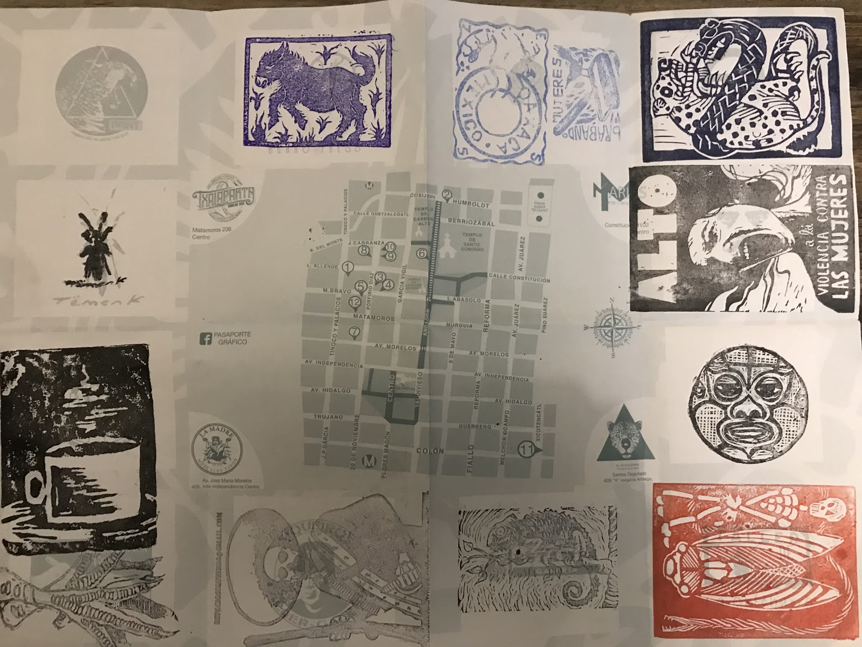
My frustratingly incomplete map from January 2019.

Each of the 12 galleries highlighted on the map has its own reputation, appearance, and feel. Espacio Zapata, named after Emiliano Zapata of the Mexican Revolution, features some of ASARO’s political work, while Taller de Gráfica la Chicharra displays art from dozens of independent artists. Each shop is staffed by working artists who have a personal connection to the art around them, reflecting just how much meaning urban art has come to hold for people in Oaxaca.

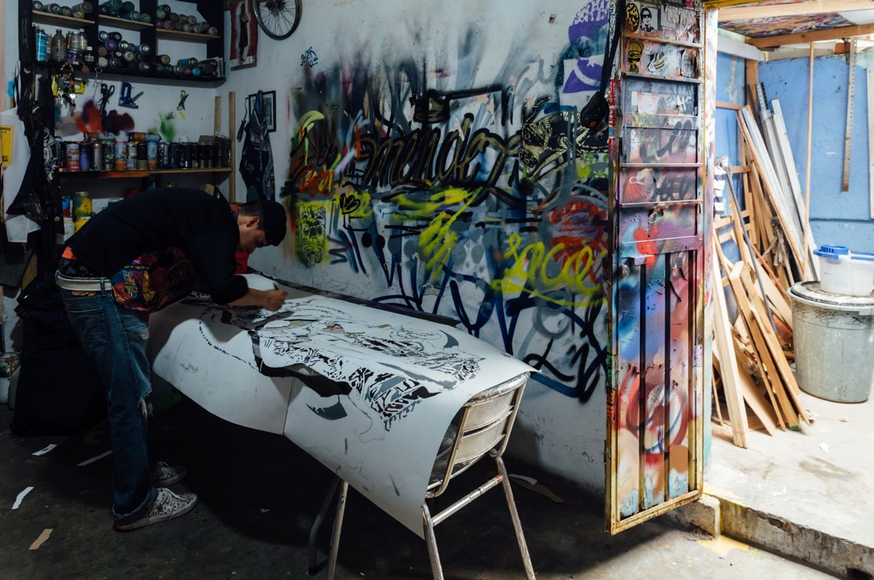
One of Yescka’s partners works on shaping a stencil that will be used in a future project.

All that being said, this push to bring more visitors to Oaxaca to purchase art begs the question, “How is the commodification and popularization of urban art changing the way it functions in Mexico?” Though I struggled to identify a concrete answer to this question in my time in Oaxaca, my return to Mexico City ushered in some ideas.

Chapter 9: Mexico City Today
In the previous chapter, I provided an account of my own understanding of Oaxaca today and touched on the legal policies surrounding urban art. In this section, I will turn my attention to Mexico City, the capital of Mexico, to find both commonalities and differences between both regions.
Unlike Oaxaca, Mexico City has not been as powerfully rocked by a major social movement quite as recently. Still, the legacy of the aforementioned disappeared students of 2014 is very much present, when you know where to look. To combat my own distance from this event as an American student who was only slightly familiar with it at the time, I relied on interviews with people who had lived through it themselves. What follows is a look into the culture of Mexico City’s contemporary art community, which I believe to be particularly compelling when considered in comparison to that of Oaxaca.
Setting the Scene
In some aspects, Mexico City and Oaxaca are strongly intertwined. Many of the artists I met often travel between the cities for different commissioned projects, and their work deals with some of the same subject matter. Like Oaxaca, Mexico City is home to a vibrant artistic community, but it has roughly 150 museums – nearly the most museums in the world – and bolsters a population that is roughly 36 times that of Oaxaca’s. In this way, the two cities feel worlds apart.
In my three weeks in Oaxaca in 2019, it was not uncommon to run into people I knew, sometimes even multiple times in a day. In Mexico City, though, serendipitous encounters seemed next-to impossible. Skyscrapers dominate the skyline. Thousands of people travel throughout the city on the subway each day in their own underground world. Cars are raised and lowered every minute in multi-level parking structures. Sirens fill what, in Oaxaca, would be a silent night.
Legality of Urban Art in Mexico City
Another difference between Oaxaca and Mexico City is the legality of art in public spaces. This primarily has to do with the sheer number of buildings that are painted illegally in the capital. According to Humberto Reyes, the leader of la Unidad Graffiti (the Graffiti Unit), seven out of every ten monuments and historic buildings has been vandalized with paint. The Graffiti Unit falls within the Secretary of Public Security (SSP) and was formed in 2003 in an effort to restore graffiti-painted spaces and round up and arrest graffiti taggers (Milenio).
Just three years later, the unit’s goals shifted. “Originally these acts were considered vandalism,” said Reyes. “The unit became aware that these were not acts of destruction, but an artistic manifestation that demanded its own space” (Milenio). The Graffiti Unit officially redefined its mission as, “To give young people fair and free spaces to paint legally, accompanied by a police control car.” Unit members did this because they believed that by opening up spaces in which artists can paint, artists would be more encouraged to paint “pleasing” works, explains Al Jazeera reporter, Rachel Levin.
In 2017, 8,000 graffiti artists were given sensitization talks about spaces where they can paint in accordance with a previously agreed-upon theme to lead them away from illegal painting (Milenio). Still, Mexico City continues to be overtaken by urban art, much of which is illegal. Authorities cited in this same report say that six of the 16 boroughs of Mexico City see most of the graffiti: Iztapalapa, Iztacalco, Álvaro Obregón, Gustavo A. Madero, Cuauhtémoc, and Miguel Hidalgo.
Some community members view this prevalence of urban art as a positive addition to the culture of Mexico and compare it to the art that emerged in the time of the Big Three. Danae Pedroza of the Diego Rivera Mural Museum says that, “Whereas Orozco, Siqueiros and Rivera go over the past, the new artists do that too, but using more recent histories such as drug violence and recent social problems. There’s a much more rebellious tone and much more creative freedom, because they are free spaces – the streets” (Levin).
Though some people like Pedroza attribute positive characteristics to urban art, others view it as a nuisance. Artistic expression or “vandalism” – however you choose to define it – poses a challenge to restoration specialists from INAH, the National Institute of Anthropology and History, because historic buildings can be up to 300 years old and are often difficult to repair: “Each piece or building comes from a different time, often built with imported materials, making any reparation very expensive,” said José Mariano Leyva Pérez Gay, director of Mexico City’s Historic Center Trust (Milenio). According to Mexico News Daily, it is because of the challenges associated with repainting historic buildings that Mexico City can choose to punish graffiti artists working illegally with fines of up to 1,509 pesos (US $83) and 36 hours of jail time.
For muralist Paola Delfín, painting in Mexico’s capital presents greater challenges than those in Oaxaca or other regions: “If you want to paint here in the city, it’s tough. I tried doing a tiny festival here, but no. It’s a bureaucratic nightmare. You need permits.” Although Delfín has had an easier time when building owners give her permission for small works, she finds getting authorization to paint more sizeable works to be a big challenge: “It’s a lot harder. I don’t know where to start.”
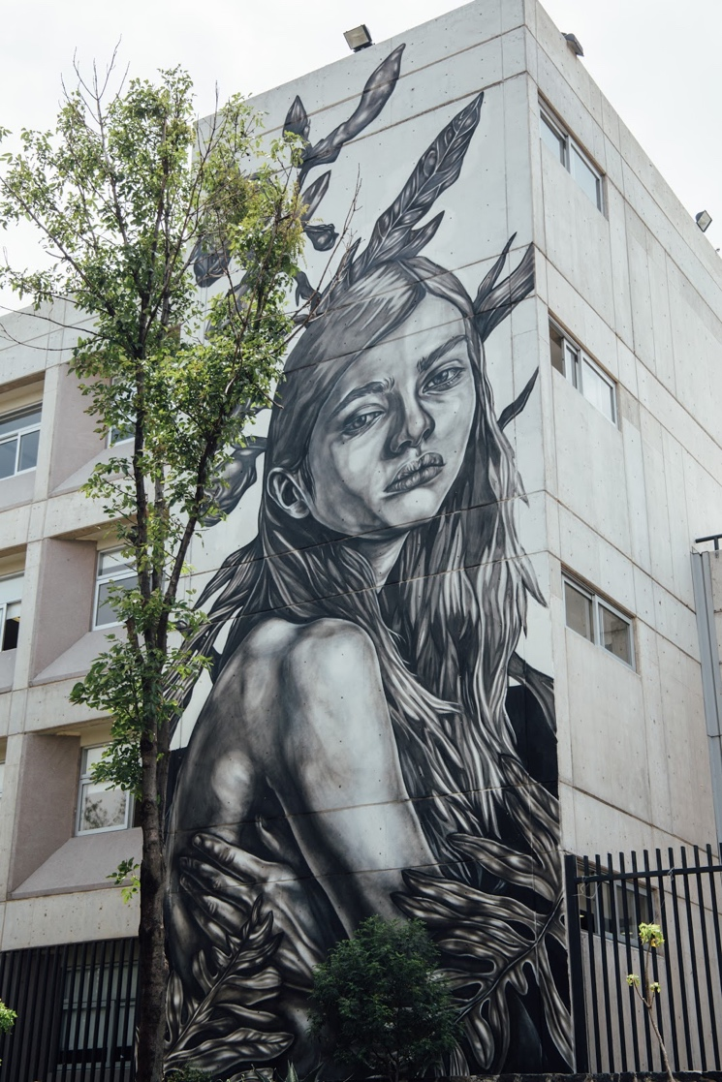
Delfín was given permission to paint a large-scale mural on one of the buildings on UNAM’s Political and Social Science campus.

Festivals and Governmental Funding of Urban Art
One thing especially unique to Mexico City when compared to Oaxaca is the present-day push for urban art in public spaces, as supported by federal funding efforts. Every year, money is raised and given to artists from around the world to come and create murals in the historic center. Fortunately for Paula Delfin, she is one of the prominent artists who has been commissioned by the city itself to create large murals in public spaces, and she has had the opportunity to paint large-scale pieces in the center of the city during multiple festivals. Delfín had this to say about the work that she currently does:
All the projects are different. Some of them are commissioned by the local government, or they are interested in changing the vision of the location to add a little bit of culture or so people can get interested in looking around. Sometimes there are political themes mixed in there. It depends on how political you are or if you get involved in the project or not. It depends. It’s pretty cool that a city would be interested in implementing a little bit of culture and sharing it with the public.

While there are obvious fiscal and aesthetical benefits to doing government-funded works, there are some points of contention as well within the art community. Mexico City-based artist DUSK views works sponsored by the government as problematic, in that artists are creating work for the people in power – not necessarily for the general public. He goes as far as to categorize sponsored works as a form of cultural colonization:
Muralism comes from Mexico. And if you look back at the history, well, how many of the murals of Rivera, Siqueiros, or Tamayo did they not censor? Because they were saying things that made people uncomfortable. Whereas, now it’s like, they pay the ones who paint what they want. So… I don’t know, maybe the conditions are different. Maybe we’re more neoliberal than anything else, where if we don’t have money, we can’t do anything. But it’s tough that we sell ourselves like that. A lot of other people sell their talent for decoration. It’s no longer relevant. Nothing’s happening anymore. For how [murals] are, they don’t say anything.

Israel Isk, a political artist and a member of the Zapatista Army for Liberation, is also critical of artists who agree to paint in accordance with the government’s requests:
That’s when it calls into the question the integrity of every artist, how much the artist will permit. Two things can happen: One, that the artist sells themselves, or that the artist takes that money to produce and get out of that circle. That’s also what I want to do, get the resources of that system and to leave before that system absorbs me.

Creative Spaces and the People Within Them
It can be difficult to establish and maintain a sense of connection in such a densely populated city as Mexico's capital. For that reason, many artists choose to involve themselves in art-focused communities. All the artists I interviewed reported belonging to at least one art-affiliated group, and for many of them, these groups are much more than just communities of people with shared interests. They can help artists understand their work in new ways, and give them a space in which to consider the impact they want to have on the environments they exist in.
ATEA
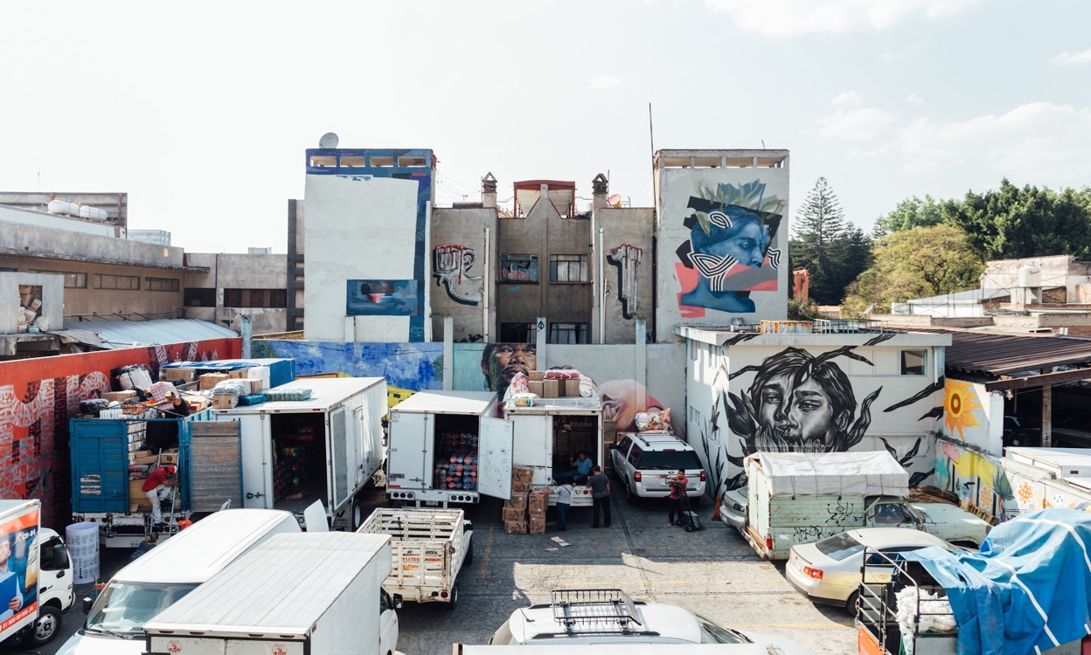A large parking lot is located across from ATEA. Artists from Mexico and other parts of the world are invited to paint new murals every year.

In December 2010, a group of artists founded Arte Taller Estudio Arquitectura (ATEA), a creative space located in the La Merced neighborhood. According to the collective’s Facebook page, “ATEA seeks to promote and generate a cross platform dialogue that responds to current social conditions, across different disciplines (architecture, contemporary art, film, music and urban research), while extending the architectonic-artistic practice to community participation and collective creation.”

El Ahuehuete
From the outside, el Ahuehuete looks like a dilapidated building awaiting demolition, but historically, it was a site to see. The lot where el Ahuehuete stands today used to be Club Condesa, a women-only swim club that operated as a meeting place for women to gather both recreationally and intellectually in the 1940s. It was a valuable space in a time when women still lacked the right to vote but wanted to discuss politics and current events. Club Condesa became coed in the 1960s and eventually shut its doors in 2015 due to the growing competition of other recreation centers and gyms, but it was appropriated by a small group of urban artists who have since used the space for their own means.
Today, el Ahuehuete is another space that fosters a tight-knit community within Mexico City. It can be described as a nontraditional gallery space that even doubles as a home for a few select artists. Under the ownership of curator and art historian Angelica Montes Cruz, el Ahuehuete commemorates an important aspect of Mexico’s history, while also adding new meaning to it. Since 2015, more than 50 artists have used the space to create large-scale works and to gather together for public exhibitions.

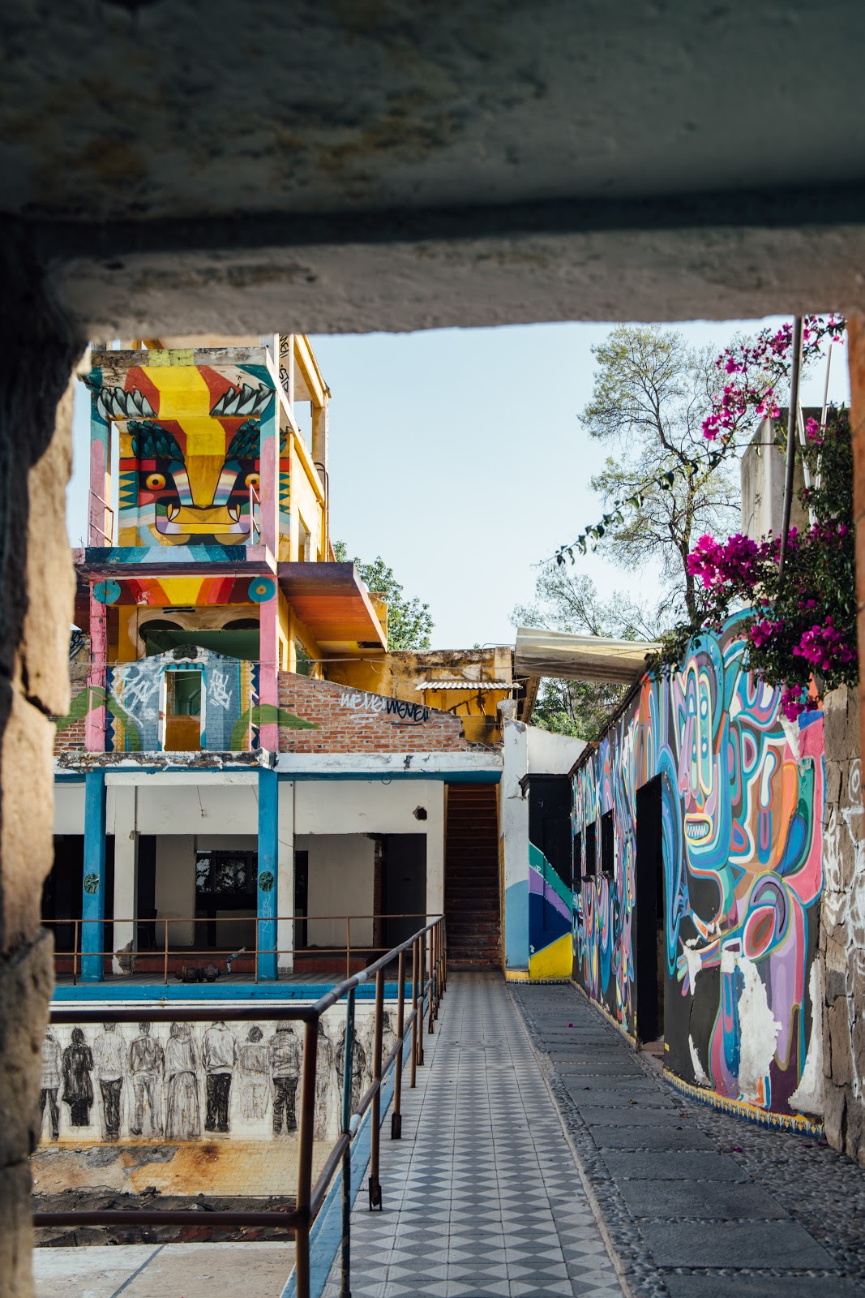
Since Club Condesa closed, artists have painted the multi-level diving board, the pool, and the walls around it with dozens of pieces.

Perhaps more than any other artist, Abraham León has made this space his own, living in an upstairs room that doubles as a studio. León hosts artists from around the world who hire him for private screen-printing lessons in the style specific to Mexico. He also paints medium- and large-scale works while blasting reggaetón throughout el Ahuehuete late into the night.

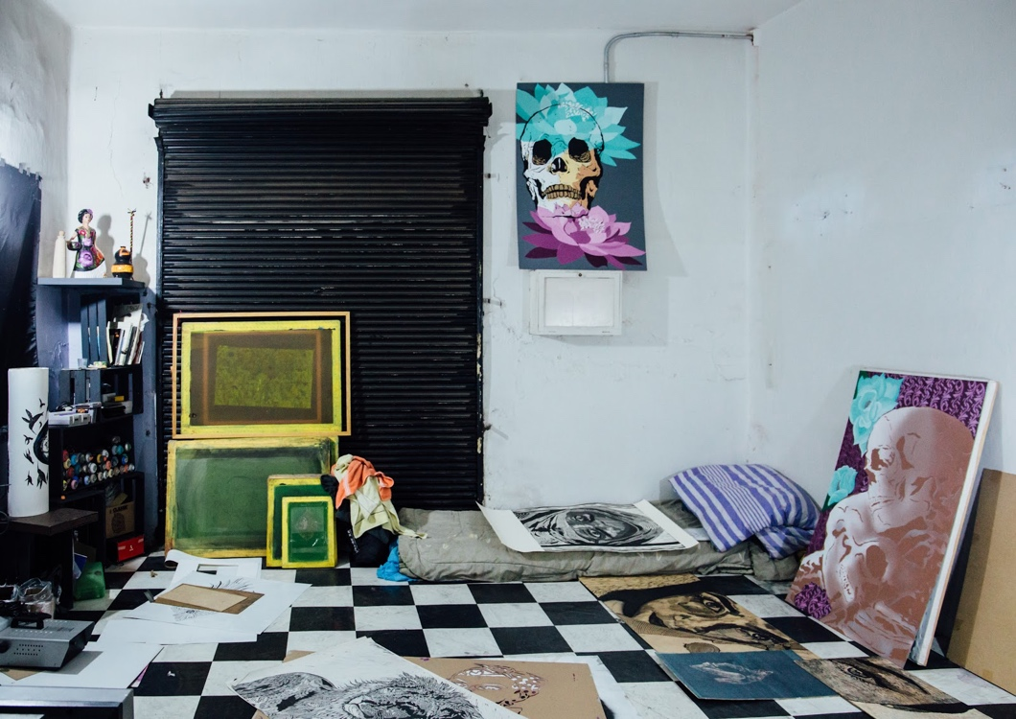
Abraham León’s studio and bedroom in August 2017.

Though el Ahuehuete is important to the many artists who gather in it, the building’s future is uncertain. Located in la Condesa, one of the most rapidly gentrifying neighborhoods in Mexico City, the lot will likely be demolished and turned into apartment buildings. Owner Cruz recognizes the value it holds now and plans to keep it as an artistic space for as long as she can: “This city is transforming constantly, devouring the past and building up the future. Art can play an important role generating discussions and action around the idea of change” (Eulich). Once el Ahuehuete is inevitably torn down, Cruz hopes to commemorate it with a plaque and also plans to push for some available space for new urban artwork. “We can’t let modernity erase our memory,” Montes says. “Whether it’s the Aztecs, a repressive government, or an exploding population, it’s something we can’t forget” (Eulich).

Chapter 10: The People Behind the Art
Up to this point, I have explored and synthesized Mexico’s history, sociopolitical landscape, and art scene, pulling largely from preexisting research. Still, what is it that real-world artists working in Oaxaca and Mexico City think about the nature of urban art and the responsibility they take on in creating it? In this chapter, I highlight some of the questions I asked interviewees during both of my trips, and group the most informative responses together as a way to show the many different ideas that surround urban art today.
Some responses supported my original hypotheses (i.e. that all urban art is essentially political, that it can, in fact, mobilize people, etc.) while others challenged it. Now, I do not believe there is one conclusive response to any of the questions that follow. Instead, the most compelling insights can be found by considering these various perspectives in relation to each other. Note that there is an appendix at the end of this thesis that lists each of the following artists, for clarity’s sake.
Is all urban art inherently political? If not, should it be?
When I began this research, I considered the very act of creating art as inherently political – something that is intended to influence a public through conveying a message. However, not all the artists I spoke with share this belief. For some, the very act of painting on a public wall is political – a form of defying the state and promoting one’s own sets of ideas. For others, it is merely a medium through which to express creativity. Israel Isk, a political artist and Zapatista, believes that artists have a responsibility to question the systems that govern them and create political works:

Is all art political? No. It should be. Mario Benedetti criticized in the 80s the culture and Mexican art because he said the art was precious and flattering for the government and politically correct. The art that is currently in exhibition in whatever part of Mexico is art that is not going to criticize or question the economic or political system or globalization. It won’t question it. But also, because those same institutions and galleries depend on a government. In exchange, what is going on in the streets and sometimes illegal does question the appropriation of the public space, it does try to send out the message to the masses and to question. But for that, it doesn’t require permission and doesn’t try to enter the institution. If it were to enter the institution, the political art loses its purpose.

Pilar Fusca, a well-known muralist in the urban art community, sees political art as more negative than positive, because of the way it excludes some people from the conversation:
I think a lot of the ideas that artists have are political. And for me, that doesn’t work, because when you put yourself on the side of the people, or of the government, it’s like a small percentage of what the whole people think, or feel, or see. So, for me, to portray a political idea in a mural – I’m not speaking for everybody. And my natural view of things is really in coherence with everybody. [As a muralist] I want to get both viewers looking at what I have to say, because my point of view is always convergent. For me, being political means that I have to cut some people out of the perspective, and I think there’s always a wider perspective that you can put everyone into. I don’t believe in partial political views. I think it breaks us as humans when you are partial, and when you have so much power as an artist to say something, and then you say something that is partial, I think it’s sad. Deep down, there’s something that must connect us all together, and that’s the point that I’m looking for when I paint a wall - or when I make any painting. Like, the things that we all possess, not just the believers in this and believers in that.

DUSK’s opinions, on the other hand, fall on the polar opposite end of the spectrum:
We’re not here to please people. We’re not here to like decorate. I think we’re here to ask questions and to make visible the things [people] don’t want to see, and to make visible the things they want to brush aside. Really, it’s the programs (government-funded mural projects) that can practice in the public space but don’t take the community into account. . I think the only one who benefits is the government and the companies [involved]. The public doesn’t benefit, the artist doesn’t benefit, nobody does. The only one who gains anything is them.

For Paola Delfín, points of view are critical, but not necessarily meant to be expressed in every work of art:
I think it is important for people to have political stances. I can have my own political opinion and I can try to change my ways, but I don’t always have to do it with my paintings. If I do it just to do it, it doesn’t make sense. If you do it genuinely, it’s pretty cool. But I think if you don’t do it, it doesn’t take merit away from your work.

How does art operate as a form of communication?
In Art & Social Movements, McCaughan argues that art is a powerful form of communication. But do other artists in Oaxaca agree? Here’s what Yescka had to say:
Urban art or street art are forms of public press in different ways. The moment you put something on the street it becomes something public. Your way of feeling or seeing things or your thoughts, you are expressing everything. It’s like going out onto the street and yelling, but I don’t like yelling. If you go out into the street and put something out there, something that is yours, something concrete, something direct, or something indirect – whatever you want to say. I think these are spaces where people will pass by and a lot of people will see. It’s a way of communicating that’s really important. For example, for people like us who want to leave political messages, it’s a super important platform for us because people will see what we want them to see, or what we see is going on, or what we think people are feeling. It’s a form of communication, at the end of the day. I think people call it street art, but I think I could say that before in the prehistoric period, it was rock art. It’s the same. In the spaces outside or in the caves or walls. It’s precisely that, it was the idea of leaving a story, a mark, so the people could see something important.

For Pilar Fusca, urban art’s power is in its inclusivity: “When I think about democracy, I think about the street, because the street is the most democratic thing out there. Everybody is entitled to speak on the street, because the street is for everybody. What I’m trying to say is that you can do whatever you want on the street. You own a piece of it, because you’re a citizen.”

Paola Delfín recognizes the value of being exposed to different perspectives through a visual medium:
There are so many branches of street art or ‘muralism.’ There are so many ideas and ways of broadcasting those ideas. I sometimes don’t share the same ideas, but that’s the cool thing. Now people are more open-minded to receiving things that they weren’t used to. Now, I say, maybe I don’t like that wall with those colors, but I understand that people will receive it with happiness because it might change the way people walk down the streets when it’s gloomy out, and there is a wall full of colors, and they like it.

How does being in the public space impact art itself?
An artist at the beginning of her career, Katalina Manzano already recognizes that without tapping into the cultural context of a space, urban artists’ work is limited:
Well, if you don’t listen to or read the street well you craft is going to die. They ask me about the sketch or the image and I say well I work alone, but when you get to the wall, the wall starts to tell you things depending on the color or the type of construction. Or what is in front of you or the colors that are around or the type of people who pass by who inhabit that area. I am always dealing with that. People who pass by can tell you if they don’t like it or they like it. It’s like you generate a language with them. If you don’t start thinking about that, you close yourself off and your work can be dismissed. I think that’s the most important thing. And above all, the quality that one finds at the moment of the interaction and creating this relationship with people by being on the street. It gives you life. You can be having a terrible day and people can motivate you; they will talk to you or say hi or take a picture. You can get to know people from different parts. You start to create a dialogue. All of that is part of being on the street and what you have to listen to.

For Yescka, urban art’s accessibility is what most sets it apart:
For me public spaces are very important for communication. It’s not the same, having a piece that has a lot of force in your house or a closed space, instead of having it outside. And public spaces are free; you don’t have to pay. You can make your propaganda or about what you think about, your techniques, and it’s there. It’s valid. I saw this the most in 2006. The street became something interesting, something to use to interact with the public and communicate with them.

Nando Lelo tests the impact of his work by observing how people physically react to it:
I can’t measure it. I can’t measure how much of a negative impact it has had or how much of a positive impact it has had. But when I know that I make something bad, people will erase it or people will wonder why was this painted. And that’s when you realize that it does cause something, it does have an effect. If it is not erased, it is a little check of “That’s O.K.,” keep doing it. In that case I think it is a positive thing.

What does it take for something to qualify as “art,” or for someone to be an artist?

Pilar Fusca believes everyone can and should make art:
To be an artist for me is to be just one thing. But I think art is something that every person should do, because it’s creating something that is not out there. It’s creating all this logic - not just an object, but all this logic and structure behind it, to give to other people. And I think any person can do that. You don’t have to do something ‘artsy,’ you can just make things happen. And for me that is art.

Itandehui Franco Ortiz advocates for an expanded definition of what constitutes “art”:
I think every person gives their own definition. It’s a very debated word and it will always be like that. But I would like to highlight that if I categorize [graffiti] as art, it is also outside the standard definition related to galleries and museums, more closed off and more institutional. It is important for us to know that this term can also be applied to things done out on the street. A delinquent can be an artist – those things can go together. I studied a masters in art. What I was interested in was not to enter closed off, elitist contexts. On the contrary, it was to understand the language, to understand the academic language, the museum language, and say this same language can be applied to the guy who is painting on the street who barely finished elementary school, somebody who you would never imagine or categorize as an artist, but who does the same and can do the same. Somebody who has the capacity to do so as somebody who is classified as an artist. The same person can conceptualize the art, they can have the same quality of technique and same support. Still has the medium to transmit what this person is thinking about, it can be something that can make you reflect and analyze, whether or not you call it art.

Do artists have a responsibility to communicate a specific message through their work?
Israel Isk argues that they do:
I think that there are a lot of things that need to be said and I think especially the current political situation in Mexico and the economic [situation] is really difficult. And outside of Mexico, you get the news of what it’s like to live here and in that sense, I think it seems necessary and responsible to send out a message and that message needs to leave, exit the gallery and the museum. And in that way, we need to take the street as a democratic space that has a tremendous reach compared to the gallery or a museum that is a closed space. The street, anybody can look at it and, in that sense, it interests me to use the street to give a message and to demonstrate the work and so that people can get to know me… I think also taking the street should be a responsible act. Because people who are going to see the message can be the person who sweeps or the person who works in the office. And not everybody will have a background in art so we have to be responsible to think about what message we are going to want to send out and where. An artist cannot go and paint the Palacio de Bellas Artes, but they can go and paint the sidewalk. You have to know where to place that message and how to place it in a manner that is pleasurable to look at and aesthetic and that will also be seen. And after being seen, it will be questioned and will create a response.

Katalina Manzano is more hesitant to take a side:
Well I don’t really know what to tell you. I think there is a little bit of everything. I don’t think I could generalize. I know artists that are much more conscious of the implications of street art, urban art. There are people who do not do street art and it is clear in their work. There are people who are in between who do it and don’t really do it, or there is a discourse and there is not or they sold their work really well and they are done. There is a little bit of everything. I think it’s a little bit personal. I think as long as you are sincere, it goes well. When you are not real about the work, what’s the point? What’s the point of feeling like an artist? I think [art] is an incredible thing to produce. It is all valid. It’s about being sincere and accomplishing something.

What is the role of photography in preserving an otherwise-fleeting medium?
As a photographer, Itandehui Franco Ortiz ultimately sees the value in documenting urban art:
Sometimes it can be something contradictory because graffiti is something that was born on the street and illegal and it’s supposed to be something spontaneous. It was never designed to be something permanent. On the contrary, you know that if you paint something on the street, sooner or later somebody is going to take it down. That’s how it is. That’s how the street is. Within this understanding, you see the necessity of documenting and registering these projects for the future. Oaxaca is a small place and graffiti artists know what other graffiti artists are doing. But in bigger places, people do not know what people are doing in Oaxaca.
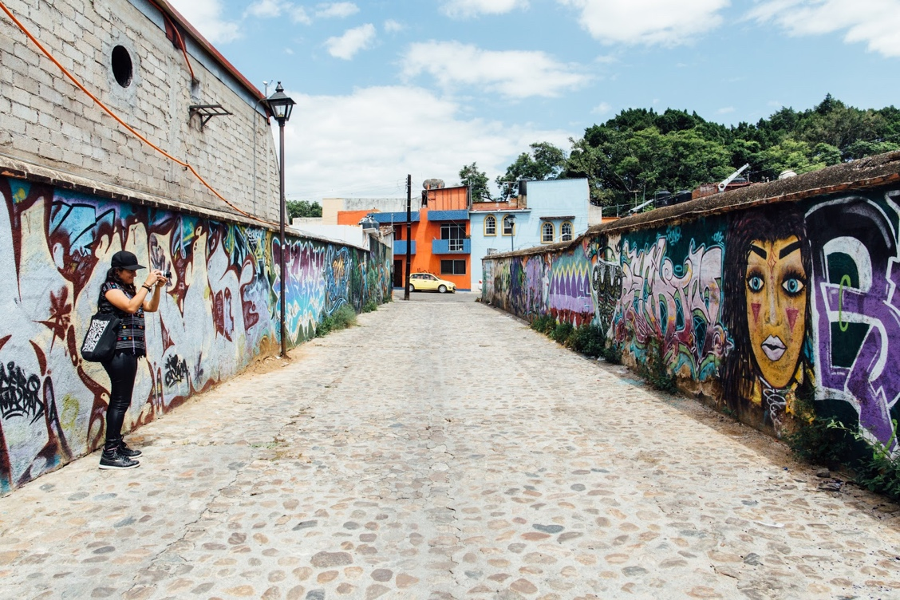
Itandehui Franco Ortiz photographs new work in the Xochimilco neighborhood of Oaxaca.

Ortiz uses photography to document urban art and does not think it’s about changing people’s perceptions. It’s more about letting people see other perspectives: “At the end of the day, people are going to have their own criteria for liking something. But at least they are being exposed to it and they know other work exists. I also know that the tool of photography isn’t going to tell you everything. But maybe with my writing, there is a clearer message or slant.”

Chapter 11: The Intersection of Urban Art and Gentrification
Before concluding my thesis, I will briefly explore the connection that exists between urban art and gentrification. Although urban art has only been more popularized recently, its presence in urban areas has already impacted housing and living costs in various neighborhoods, and it will, according to experts, only continue to grow in scope and impact in the years ahead. In the discussion that follows, I refer to gentrification and base my understanding of it in the definition outlined by Gillian White for The Atlantic: “Gentrification is used to describe the many different ways through which money and development enter poorer or less developed neighborhoods, changing them both economically and demographically.”
Largely due to its housing bubble, Mexico has been transformed in recent years, with floods of money displacing long-term, low-income residents. In his Huffington Post article, Miguel Marshall explains that Mexico, “a country with a population of 112 million people living in 28.6 million households, has a hungry demand for housing, reaching beyond 1 million units per year with a 50% underserved housing market.”
While some cities like Monterrey and Guadalajara have remained fairly stable in terms of pricing, Mexico City has undergone a major transformation in the last decade, largely due to the city’s skyrocketing cost of housing. In 2008, at present value, the average housing price in Mexico City was nearly 1.5 million pesos, whereas today, that has more than doubled, reaching 4 million pesos according to Softec (Cantera). Housing experts attribute this facet of Mexico City’s housing challenge to the fact that the housing industry is 50 thousand homes short of meeting the population’s demand, which drives rent prices up and forces people of lower economic status to the outskirts.
As Maya Kroth describes in “Meet the Patron Saint of Resisting Gentrification” for Citylab, “With the Mexican capital topping so many travel magazines' ‘hot lists,’ the Airbnb effect (among other forces) has led rents to more than double in some parts of town in just a few years. Developers eye these leafy, walkable neighborhoods, centrally located and lined with gorgeous but crumbling turn-of-the-century mansions, and see dollar signs.”
Kroth goes on to say, “In Mexico, which rivals the Democratic Republic of the Congo in income inequality, displacement by gentrification has only made things worse. And corruption from real estate speculators and local politicians—even the agencies charged with protecting landmark buildings from predatory development—ensures that the process continues almost unimpeded. Registered historic buildings are illegally torn down all the time, and there are rarely any consequences.”
Art and Gentrification
Gentrification is a complex topic, which explains why so many cities are unsure of how to combat it. But it’s about more than the quantity of available housing and the costs of living. Culture is at the core of gentrification, and artists are, whether they recognize it or not, contributing to the migration patterns taking place in places like Mexico City in a powerful way. Artist Sandra Valenzuela argues, “Artists are often the first wave of gentrification, and we need to recognize our role in that” (Eulich). Valenzuela recognizes that artists often go into neighborhoods before they are hip because there is more space for a smaller price tag, but in time, artists end up helping builders for free. Then, they leave for the next affordable and soon-to-be-cool neighborhood (Eulich).
A relevant concept in this discussion is “artwashing,” a process in which urban art is situated as a value-adding amenity with the capacity to increase property values and economically revive ailing urban neighborhoods. In her master’s thesis, Mackenzie Sheldon argues, “In recent years, the commissioning of street art by public and private actors has come to be one of the most conspicuous tools utilized in the neoliberal reshaping of urban public space.” She adds, “Although some urban artists collaborate with developers in this process of artwashing, – under the auspices of gaining more exposure for their art or for art in general – many urban artists and other citizens are excluded from and/or displaced by this transformation” (2).
Considering the many artist perspectives highlighted in the previous chapter, this exclusionary aspect of artwashing contradicts urban art at its core, stripping it of its democratic properties and commodifying it. Still, though some artists consciously choose to participate in this form of work, despite its link to gentrification, other artists, like Sandra Valenzuela and Jorge Baca, are using the arts to directly combat the process.
The Saint of Anti-Gentrification
After moving into a run-down apartment she purchased in the quickly gentrifying neighborhood of Santa Maria la Ribera, Valenzuela found a small wooden figurine believed to have started out in the world as a religious relic popular at the turn of the last century (Eulich). Valenzuela named the 12-inch-tall female figurine Mari – short for Santa Mari La Juaricua – and established her as the saint of anti-gentrification.
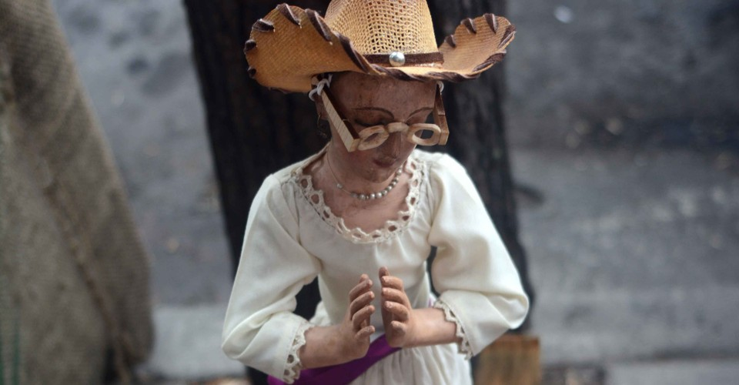
Santa Mari La Juaricua is carved out of wood and stands at about 12 inches tall. Source: Brenda Santos de la C.

With Baca’s help, Valenzuela “turned the discovery into an art project that taps into Mexico's deeply Catholic roots and the uncertainty, misinformation and economic inequalities that surround rapidly gentrifying neighborhoods in Mexico's capital” (Eulich). The goal of this project is to draw attention to the growing inequality in some of Mexico City's most historic neighborhoods, and Baca hopes Mari will spark conversations about the darker side of gentrification instead of the superficial neighborhood improvements often touted: “Your sidewalks are fixed, you get working street lights, someone plants trees, old buildings are repainted. In the middle class and below, there are people who are so forgotten in terms of social or city services that they confuse this with progress” (Eulich).

Chapter 12: Conclusion
In this thesis, I provided an overview of the Mexican Revolution and the key figures who shaped the muralism movement. I summarized some of the major events of the 20th and 21st centuries, looking specifically at the regions of Oaxaca and Mexico City. I gave examples of the art that was born in these social movements. Lastly, I incorporated the perspectives of artists working in these regions today. Still, in looking at my thesis holistically, I want to acknowledge the areas that have potential for future development – the questions that remain unanswered, but that need to be asked.
Areas for Future Research
This research spans a three-year period, which in some ways gives it the opportunity to highlight the ephemeral state of urban art through showing shifts over time. However, I believe that a study that looks at the artistic and social changes in one city over a more substantial timeframe would be of immense value, especially in the case of sociopolitical change. How will the content and style of various artists evolve with upcoming elections in the United States and Mexico? How will the function of urban art continue to change with future social movements?
Additionally, while this thesis looks at artists working in Oaxaca and Mexico City, it does not include artists working in other cities like those along the border. How do ideas about the function of art vary, depending on region? What do they look like in areas with especially strict laws surrounding public art? And how might people working in these different social contexts define an artist’s personal responsibility?
In terms of technological advancements, mixed reality and artificial reality could potentially increase art’s visibility, along with other digital imaging programs like 360-degree video. But how would sharing context-dependent art in a format that removes it from its environment impact the way it is understood and interpreted?
These are just some of the newer questions that have captured my curiosity, and I hope to see them answered in future research. But what I want to emphasize is that these questions should be informed by the perspectives that are often missing from the conversation – by the artists working day in and day out, who are not motivated by fame or accolades, but by raw passion and spirit. I am optimistic that future researchers will find these people, because they have so much to contribute – not only to the scholarship surrounding urban art, but to the ways we understand the world and the role art plays within it.
Personal Takeaways
Looking ahead to the future, there is no way of knowing whether urban art will continue to be used in the same ways I have outlined in this thesis, or if it will evolve to take on new functions – maybe even a new purpose altogether. In terms of policy, that is beyond prediction, too. People with Mexican passports might be able to travel freely across the U.S.-Mexico border, or restrictions may limit them even more. But if I am confident in anything after doing this research and immersing myself within various communities of artists, it’s this: urban art is a powerful tool. It can be used to communicate across points of difference, to shape attitudes and individual senses of self, to drive people to mobilize and to preserve cultural testimony.
The walls throughout Mexico tell the country’s unofficial story, and in doing so, the ephemeral medium of urban art leaves a permanent mark. Through studying urban art, we can acquire new knowledge that goes against hegemonic, sometimes inaccurate narratives, and better understand the world we live in. Urban art deserves to be considered as a legitimate cultural text, and the artists of Mexico demonstrate why.
Appendix
Meet the Artists

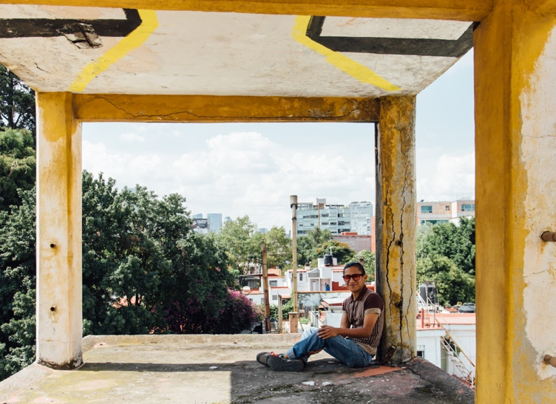
Abraham Leon
Origin: Oaxaca, Mexico
Current location: Mexico City
Focus: Screen-printing
Interviewed: Summer 2017 and winter 2019 (Oaxaca and Mexico City)
Instagram: @ab_leon

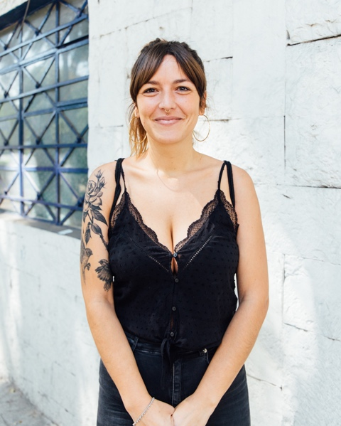
Diana Bama
Origin: Valencia, Spain
Current location: Mexico City
Focus: Murals, tattoos
Interviewed: Feb. 2019 (Mexico City)
Instagram: @dianabama

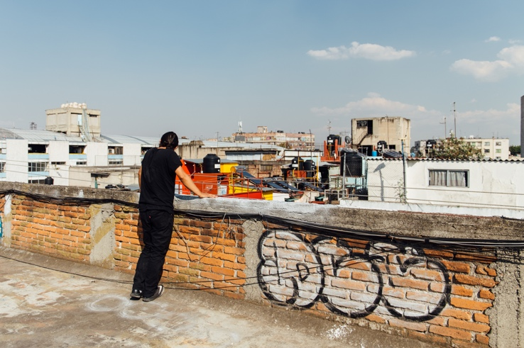
DUSK
Origin: Mexico City, Mexico
Current location: Mexico City,
Focus: Graffiti
Interviewed: Jan. 2019 (Mexico City)
Instagram: @artardeser

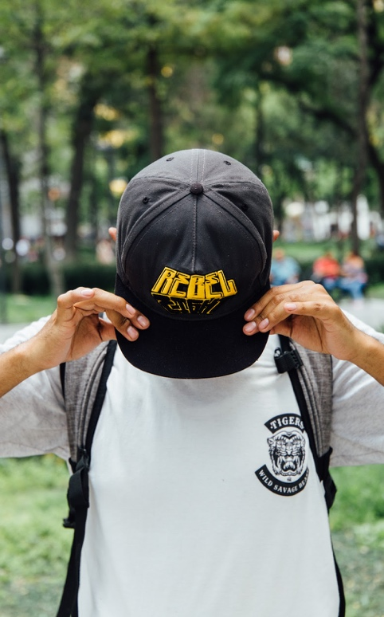Israel Isk
Origin: San Francisco Tlalcilalcalpan, Mexico
Current location: Unknown
Focus: Woodcut
Interviewed: Aug. 2017 (Mexico City)
Instagram: @isk_grafika

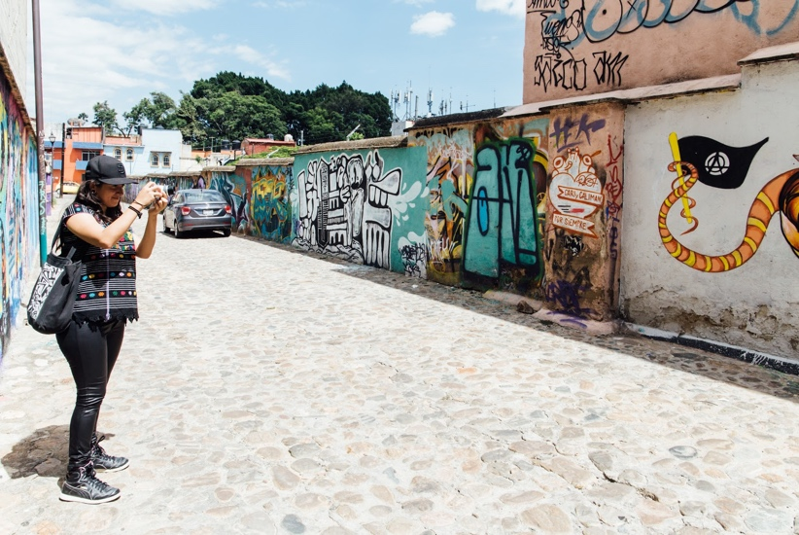Itandehui Franco Ortiz
Origin: Oaxaca, Mexico
Current location: Oaxaca, Mexico
Focus: Photography
Interviewed: Aug. 2017 (Oaxaca)
Instagram: @itandehui_xiaj_nikte

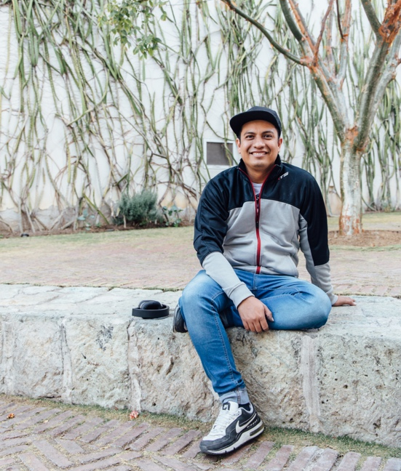
Aldo Iván Riaño Aparicio
Origin: Mexico City, Mexico
Current location: Oaxaca, Mexico
Focus: Woodcut
Interviewed: Aug. 2017, Jan. 2019 (Oaxaca)
Instagram: @riaa_ivan

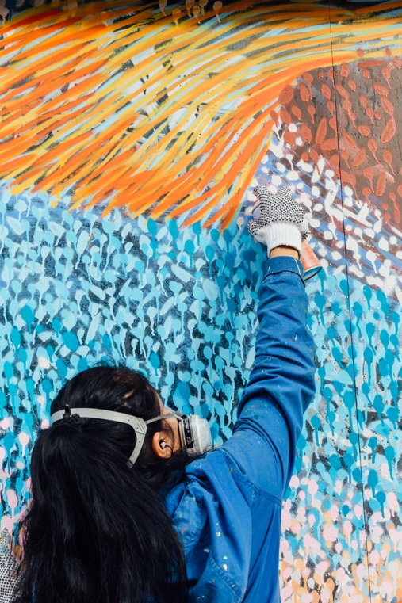
Katalina Manzano
Origin: Oaxaca, Mexico
Current location: Oaxaca, Mexico
Focus: Murals
Interviewed: Jan. 2019 (Oaxaca)
Instagram: @manzano_katalina

Nando Lelo
Origin: Unknown
Current location: Zaachila, Mexico
Focus: Murals, street art
Interview: Feb. 2019 (Mexico City)
Instagram: @lelo_zaa

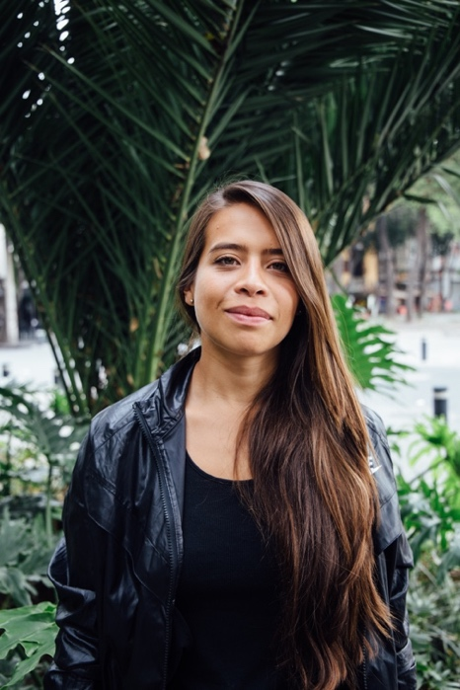
Paola Delfin
Origin: Mexico City, Mexico
Current location: Traveling
Focus: Murals
Interview: Aug. 2017 (Mexico City)
Instagram: @paola__delfin

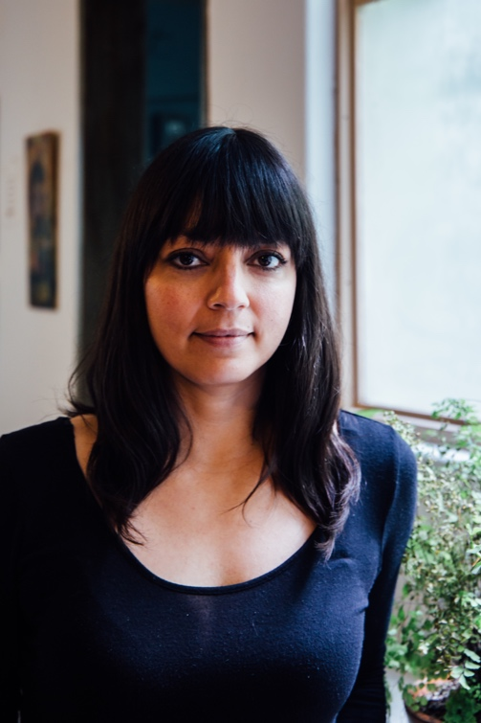
Pilar Fusca
Origin: Mexico City, Mexico
Current location: Mexico City, Mexico
Focus: Murals
Interview: Aug. 2017 (Mexico City)
Instagram: @fusca667

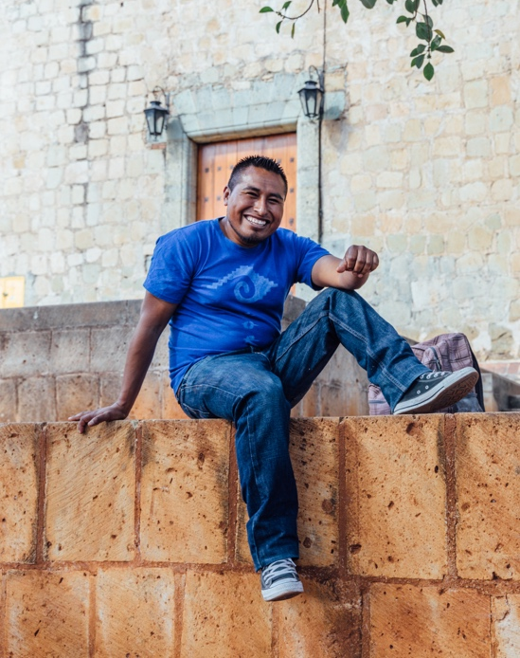
Rogelio Santos
Origin: Juxtlahuaca, Oaxaca, Mexico
Current location: San Quintín, Baja California
Focus: Painting
Interview: Jan. 2019 (Oaxaca)
Instagram: @rogelio_santos_artist

Yescka
Origin: Unknown
Current location: Oaxaca, Mexico
Focus: Painting
Interview: Jan. 2019 (Oaxaca)
Instagram: @yescka_art

Walls Transformed
Between 2017 and 2019, some of Mexico’s walls remained untouched, while others were completely covered over. Through examining the visual changes that have occurred, even over a short span of time, we can see how Mexico, itself, has changed.

Summer 2017 Winter 2019
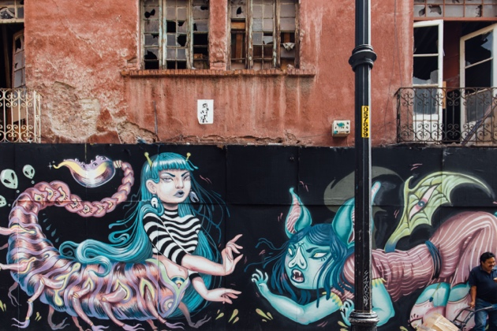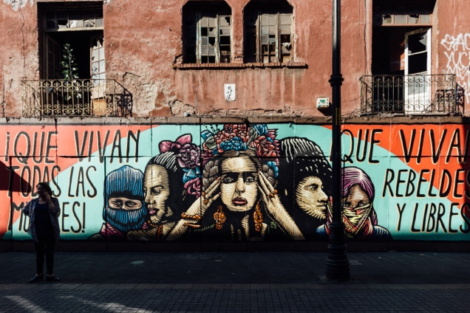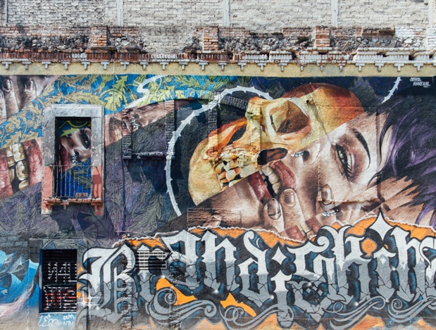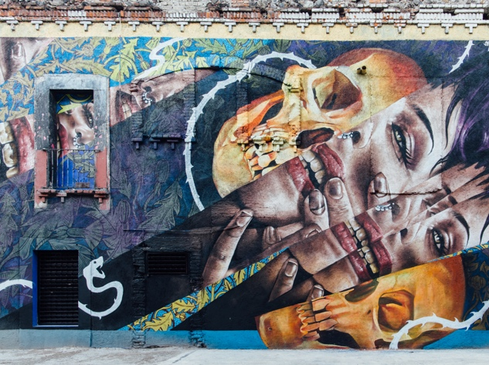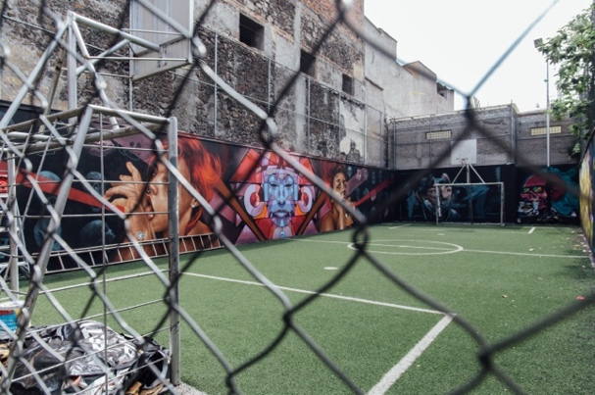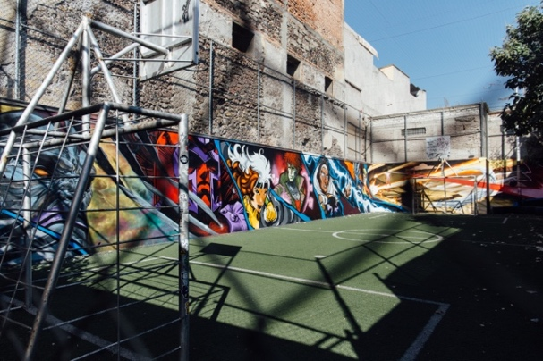

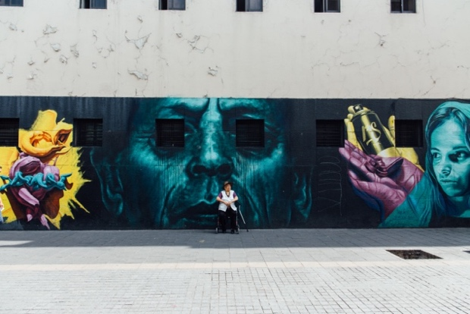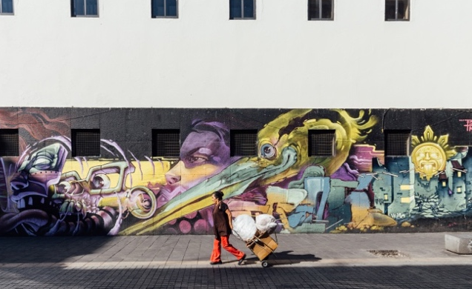

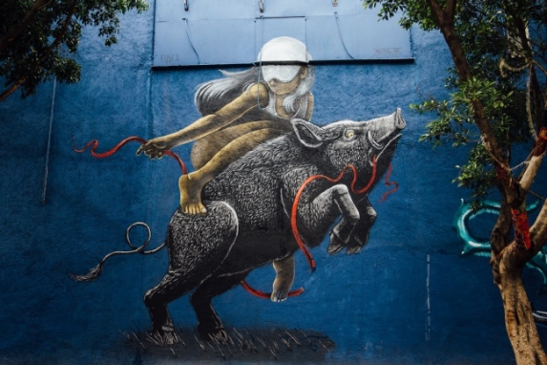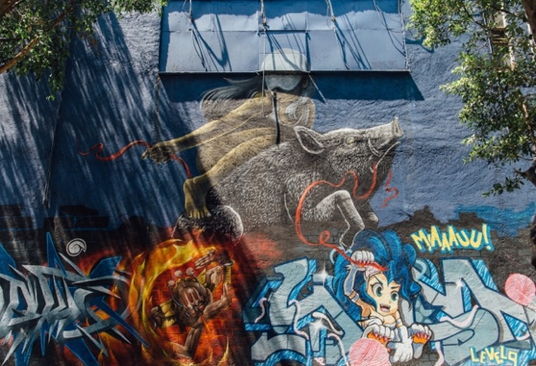

Bibliography
Adler, David. “The Mexico City Earthquake, 30 Years on: Have Its Lessons Been Forgotten?” The Guardian, Guardian News and Media, 18 Sept. 2015, www.theguardian.com/cities/2015/sep/18/mexico-city-earthquake-30-years- lessons.

Anzaldúa, Gloria. Borderlands/La Frontera: The New Mestiza. Aunt Lute Books, 1951.
Arenas, Ivan. “Rearticulating the Social: Spatial Practices, Collective Subjects, and Oaxaca's Art of Protest.” University of California, Berkeley, 2011, pp. 1–377.
ATEA. “Our Story.” Facebook, 1 Feb. 2019, www.facebook.com/ArteTallerEstudioArquitectura/.

Azuela, Alicia, et al. “Public Art, Meyer Schapiro and Mexican Muralism.” Oxford Art Journal, vol. 17, no. 1, 1994, pp. 55–59. JSTOR, www.jstor.org/stable/1360475.

Bama, Diana. Interview. Mexico City, Mexico. 18 Feb. 2019.

Blakemore, Erin. “30,000 People Were 'Disappeared' in Argentina's Dirty War. These Women Never Stopped Looking.” History.com, A&E Television Networks, 7 Mar. 2019,
www.history.com/news/mothers-plaza-de-mayo-disappeared-children-dirty-war- argentinaa.

Bolwerk, Anne, et al. “How Art Changes Your Brain: Differential Effects of Visual Art Production and Cognitive Art Evaluation on Functional Brain Connectivity.” PLOS ONE, 1 July 2014, journals.plos.org/plosone/article?id=10.1371/journal.pone.0101035.

Booth, Kate. The Democratization of Art: A Contextual Approach. Visitor Studies, 17:2, 207-221, DOI: 10.1080/10645578.2014.945353.

Budovitch, Max. “Popular Movements Against Displacement in Mexico City.” Displacement Research & Action Network, DRAN, 23 Oct. 2017,
mitdisplacement.org/dranblog/2017/10/23/popular-movements-against-displacement-in-mexico-city.

Brewster, Claire. “The Student Movement of 1968 and the Mexican Press: The Cases of ‘Excélsior’ and ‘Siempre’!” Bulletin of Latin American Research, vol. 21, no. 2, 2002, pp. 171–190. JSTOR, www.jstor.org/stable/3339451.

Breymann, Walter N. "Cientificos and the Collapse of the Diaz Regime: A Study of the Origins of Mexican Revolutionary Sentiment, 1903-1910," Journal of the Arkansas Academy of Science: Vol. 8, Article 21, 1955.
Brooks, David. “How Artists Change the World.” The New York Times, 2 Aug. 2016, www.nytimes.com/2016/08/02/opinion/how-artists-change-the-world.html.
Burton, Tony. “Did You Know? Oaxaca Is the Most Culturally Diverse State in Mexico.” Mexconnect, 2008,
www.mexconnect.com/articles/1165-did-you-know-oaxaca-is-the-most- culturally-diverse-state-in-mexico.

Cantera, Sara. “Housing Prices Double in Mexico City.” El Universal, 22 May 2018.

Cantor, Shannon. “Revolutionary Aesthetics in Post‐Revolutionary Mexico's Social Reconstruction: David Alfaro Siqueiros's ‘El Entierro De Un Obrero Sacrificado.’” Wiley Online Library, 11 May 2017, onlinelibrary.wiley.com/doi/full/10.1111/tla.12106.

Carlsen, Laura. “Ayotzinapa's Message to the World: Organize!” NACLA: Reporting on the Americas Since 1967, NACLA, 28 Sept. 2016,
nacla.org/news/2016/09/28/ayotzinapa%E2%80%99s-message-world-organize.

Casas, Arnulfo Aquino, and Jorge Perezvega. Imágenes y símbolos Del 68: fotografía y gráfica Del Movimiento Estudiantil. Universidad Nacional Autónoma De México, 2008.
Cave, Damien. “Mexico’s Not-So-Favorite Son.” The New York Times, 15 Nov. 2013, www.nytimes.com/2013/11/17/arts/design/the-legacy-of-the-painter-jose- clemente-orozco-is-revived.html.
Ciok, Amy E. “Diego Rivera.” Academic Medicine, vol. 77, no. 1, 2002,
journals.lww.com/academicmedicine/Fulltext/2002/01000/Diego_Rivera.15.asx.

“David Alfaro Siqueiros: Mexican Painter and Muralist.” The Art Story, The Art Story Foundation, 2019, www.theartstory.org/artist-siqueiros-david-alfaro.htm.

“David Alfaro Siqueiros.” The Museum of Modern Art, MoMA, 2019, www.moma.org/collection/works/61471.

Delfin, Paola. Interview. Mexico City, Mexico. 17 Aug. 2017.

Delvin, Joska. Interview. Mexico City, Mexico. 10 Aug. 2017.
Deslandes, Ann. “It Could Happen Anywhere: Anabel Hernández Reflects on Mexico's 43 Missing Students.” The Guardian, 1 May 2019, www.theguardian.com/books/2019/may/02/it-could-happen-anywhere-anabel- hernandez-reflects-on-mexicos-43-missing-students.
DUSK. Interview. Mexico City, Mexico. 23 Jan. 2019.

Easterling, Stuart. The Mexican Revolution: A Short History, 1910-1920. Haymarket Books, 2013.

Eisinger, Dale. “Police in Mexico City Are Helping Street Artists Find Walls to Paint.” Complex, 5 Jan. 2014, www.complex.com/style/2014/01/street-art-in-mexico-city-police-help-artists.

Eulich, Whitney. “Looking for a Miracle in Mexico City.” U.S. News, 27 July 2018, www.usnews.com/news/world/articles/2018-07-27/mexico-city-artists-create-a- saint-to-combat-gentrification.

Eulich, Whitney. “'Poolside' Art Dives into Mexico City's Untidy Transformation.” The Christian Science Monitor, The Christian Science Monitor, 1 Sept. 2017, www.csmonitor.com/World/Americas/2017/0901/Poolside-art-dives-into- Mexico-City-s-untidy-transformation.

Fehrenbach, T.R. Fire & Blood: A History of Mexico. Replica Books, 1999.

Figueroa, Brittney. “Officially Unofficial: The Evolution of Mexico's Student Protests.” Council on Hemispheric Affairs, COHA, 20 Apr. 2015,
www.coha.org/officially-unofficial-the-evolution-of-mexicos-student-protests/.

Folgarait, Leonard. “The Mexican Muralists and Frida Kahlo.” Oxford Research Encyclopedias,
oxfordre.com/latinamericanhistory/view/10.1093/acrefore/9780199366439.001.0001/acrefore-9780199366439-e-464.

Fusca, Pilar. Interview. Mexico City, Mexico. 14 Aug. 2017.

Ganster, Paul. “Political Change and Stability in Mexico: The Historical Context.” California Western International Law Journal, vol. 18, no. 1, 1987,
scholarlycommons.law.cwsl.edu/cgi/viewcontent.cgi?article=1495&context=cwi lj.

Goñi, Uki. “40 Years Later, the Mothers of Argentina's 'Disappeared' Refuse to Be Silent.” The Guardian, Guardian News and Media, 28 Apr. 2017, www.theguardian.com/world/2017/apr/28/mothers-plaza-de-mayo-argentina- anniversary.

González-Aguilar María, and Marta Rosso-O'Laughlin. Atando Cabos: Curso Intermedio De Español. Pearson Education, 2008.

“Grafiteado, 70% De Edificios y Monumentos Históricos.” Milenio, 12 June 2017, www.milenio.com/estados/grafiteado-70-de-edificios-y-monumentos-historicos.

“Graffiti Is a Popular Art Form in Mexico City.” Mexico News Daily, 13 June 2017, https://mexiconewsdaily.com/news/graffiti-is-a-popular-art-form-in-mexico- city/

Greenberg, Clement. Art and Culture: Critical Essays. Beacon Press, 1972.

Greenup, Ruth, and Leonard Greenup. Revolution Before Breakfast: Argentina, 1941- 1946. University Of North Carolina Press, 2011.
Griffin, Michael. “Art as Communication.” The International Encyclopedia of Communication, 10 Dec. 2015, doi:10.1002/9781405186407.wbieca055.pub2.
Grupo Mira. La Grafica Del 68: Homenaje Al Movimiento Estudiantil. 3rd ed., Grupo Mira, 1993.

Happer, Catherine, & Greg Philo. "The Role of the Media in the Construction of Public Belief and Social Change." Journal of Social and Political Psychology [Online], 1.1 (2013): 321-336. Web. 17 May. 2019

Imam, Jareen. “From Graffiti to Galleries: Street vs. Public Art.” CNN, Cable News Network, 5 Aug. 2012, www.cnn.com/2012/08/03/living/ireport-street-art- public-art/index.html.

“Indigenous Civilizations in Mexico.” Don Quijote, Don Quijote, www.donquijote.org/mexican-culture/.

Isk, Israel. Interview. Mexico City, Mexico. 12 Aug. 2017.
Jones, Sam. “Mexico's Street Art Tells Stories of Grief, Anger and Resistance.” The Guardian, 5 Feb. 2015, www.theguardian.com/global- development/2015/feb/05/mexico-oaxaca-murals-lapiztola-street-art-murals.
“José Clemente Orozco.” PBS, Public Broadcasting Service, 2 Sept. 2015,
www.pbs.org/wnet/americanmasters/jose-clemente-orozco-career-timeline/83/.

“José Clemente Orozco's Prometheus.” Pomona College Museum of Art, 3 Nov. 2017,
www.pomona.edu/museum/collections/jos%C3%A9-clemente-orozcos- prometheus.

Keyes, Allison. “Destroyed by Rockefellers, Mural Trespassed On Political Vision.” NPR,National Public Radio, 9 Mar. 2014,
www.npr.org/2014/03/09/287745199/destroyed-by-rockefellers-mural-trespassed-on-political-vision.

Kings and Generals, director. Aztecs: Arrival of Cortes and the Conquistadors. YouTube, 11 Oct.2018,
https://www.youtube.com/watch?v=suRAVIndO4Y&index=9&list=PLaBYW76inbX5xFVjwMXSPd-UFSa3LQ_mq
Kings and Generals, director. Fall of Tenochtitlan (1521) - Spanish-Aztec War. YouTube, 14 Oct. 2018, www.youtube.com/watch?v=391JhiSsByI.

Knight, Alan. “The Working Class and the Mexican Revolution, c. 1900-1920.” Journal of Latin American Studies, vol. 16, no. 1, 1984, pp. 51–79. JSTOR, www.jstor.org/stable/157287.

Knox, A. J. Graham. “Henequen Haciendas, Maya Peones, and the Mexican Revolution Promises of 1910: Reform and Reaction in Yucatan, 1910-1940.” Caribbean Studies, vol. 17, no. 1/2, 1977, pp. 55–82. JSTOR, www.jstor.org/stable/25612798.
Kroth, Maya. “Meet The Patron Saint of Resisting Gentrification.” CityLab, CityLab, 2 Oct. 2017, www.citylab.com/life/2017/10/mexico-city-santa-mari-la- juaricua/540855/.
Laufer, Peter. Interviewing: The Oregon Method. Oregon State University Press, 2014

Lelo, Nando. Interview. Mexico City, Mexico. 13 Feb. 2019.

Malvido, Adriana. “Centinelas De La Memoria, México 68.” El Universal, El Universal, 3 Oct. 2018, www.eluniversal.com.mx/columna/adriana- malvido/cultura/centinelas-de-la-memoria-mexico-68.

Manzano, Katalina. Interview. Oaxaca City, Oaxaca. 10 Jan. 2019.

Manco, Tristan. Make Your Mark: The New Urban Artists. Thames & Hudson, 2016.

Marshall, Miguel. “Lack of Rental Housing Creates Gentrification.” HuffPost, 2 Mar. 2017, https://www.huffpost.com/entry/lack-of-rental-housing-creates- gentrification_b_58b78713e4b0563cd36f64e6

Martínez, Eduardo, et al. OAXACA 2006-2016: Antagonismo, Subjetividades y Esperanza. Universidad Autónoma Benito Juárez De Oaxaca, 2016.

“Mexico.” Encyclopædia Britannica, Encyclopædia Britannica, Inc., 19 Apr. 2019,
www.britannica.com/place/Mexico/La-Reforma#ref394407.

McCaughan, Ed. Art and Social Movements: Cultural Politics in Mexico and Aztlán. Duke University Press, 2012.

McCombs, Maxwell E. Setting the Agenda: The Mass Media and Public Opinion. Polity, 2014.

“Mexico Population 2019.” Mexico Population 2019 (Demographics, Maps, Graphs), World Population Review, 2019, worldpopulationreview.com/countries/mexico-population/.

“Mexico Profile - Timeline.” BBC News, 3 Dec. 2018, www.bbc.com/news/world-latin-america-19828041.
“Mexico to Receive U.N. Help Amid Renewed Effort to Find Out What Happened to 43 Missing Students.” KTLA, Associated Press, 8 Apr. 2019, ktla.com/2019/04/08/mexico-to-receive-u-n-help-amid-renewed-effort-to-find- out-what-happened-to-43-missing-students/.
“Minorities and Indigenous Peoples in Mexico.” Minority Rights Group, Minority Rights Group International, minorityrights.org/minorities/indigenous-peoples- 4/.

Museum of Modern Art, Mexico City, Mexico. 27 Jan. 2019.

National Museum of Anthropology, Mexico City, Mexico. 27 Jan. 2019.

National Museum of History, Mexico City, Mexico. 30 Jan. 2019.

Newton, Julianne. The Burden of Visual Truth: The Role of Photojournalism in Mediating Reality. Taylor and Francis, 2013.

Ortíz, Itandehui Franco. “El deleite de la transgresión: Graffiti y gráfica política en al Ciudad de Oaxaca.” Escuela Nacional de Antropología e Historia (ENAH), Academia, 2011,
www.academia.edu/7997961/El_deleite_de_la_transgresion._Graffiti_y_gr%C3%A1ficapol%C3%ADtica_en_la_ciudad_de_Oaxaca.

Ortíz, Itandehui Franco. Interview. Oaxaca City, Oaxaca. 19 Aug. 2017.

“Patrimonial Art Exhibit.” Museum of Modern Art, Mexico City, Mexico.

“Police Are Promoting Graffiti in Mexico City.” Al Jazeera, 3 Jan. 2014,
www.aljazeera.com/video/americas/2014/01/police-are-promoting-graffiti-mexico-city-201413141237551813.html.

Poniatowska, Elena. Massacre in Mexico. Univ. of Missouri Pr., 1975.

“Recuerdan a Las Víctimas Del Álvaro Obregón 286.” El Siglo De Torreón, El Siglo De Torreón, 19 Sept. 2018,
www.elsiglodetorreon.com.mx/noticia/1500642.recuerdan-a-las-victimas-del-alvaro-obregon-286.html.

Riaño Aparicio, Aldo Iván. Interview. Oaxaca City, Oaxaca. 19 Aug. 2017.

Riaño Aparicio, Aldo Iván. Interview. Oaxaca City, Oaxaca. 11 Jan. 2019.

Rochfort, Desmond. Mexican Muralists: Orozco, Rivera, Siqueiros. Chronicle Books, 1998.

Ruiz, Maximiliano. Nuevo Mundo: Latin American Street Art. Gestalten, 2011.

Sandstedt, Lynn A., et al. Intermediate Spanish. Cengage Learning, 2008.

Santos, Rogelio. Interview. Oaxaca City, Oaxaca. 15 Jan. 2019.

Schacter, Rafael, and Fekner, John. The World Atlas of Street Art and Graffiti. Aurum Press, 2017.

Semple, Kirk. “Missing Mexican Students Suffered a Night of 'Terror,' Investigators Say.” The New York Times, 24 April 2016.
Sheldon, Mackenzie. “Urban Art and Uneven Development: The Geography of ‘Artwashing’ in Miami and Philadelphia.” University of Miami, University of Miami, 2015, pp. 1–108.
Siqueiros, David Alfaro. Manifiesto. Sala De Arte Público Siqueiros, 1923.

“Siqueiros, Muralist and Exponent of New World Proletarian Art, Dies at 77.” The New York Times, 7 Jan. 1974,
www.nytimes.com/1974/01/07/archives/siqueiros-muralist-and-exponent-of-new-world-proletarian-art-dies-a.html.

Steinkopf-Frank, Hannah Rose. “La Sape: Tracing the History and Future of the Congos' Well-Dressed Men.” The University of Oregon, Clark Honors College Theses, 2017, hdl.handle.net/1794/22898.

Stephen, Lynn. Transborder Lives: Indigenous Oaxacans in Mexico, California, and Oregon. Duke University Press, 2007.

Stephen, Lynn. We Are the Face of Oaxaca Testimony and Social Movements. Duke University Press, 2013.

“The Eagle, the Snake, and the Cactus in the Founding of Tenochtitlan.” World Digital Library, Library of Congress, 18 June 2015, www.wdl.org/en/item/6749/.

The Storm That Swept Mexico. Directed by Ray Telles, Paradigm Productions, 2011.

“This Week in History: The Tlatelolco Massacre.” People's World, 1 Oct. 2018.
https://www.peoplesworld.org/article/this-week-in-history-the-tlatelolco- massacre/

Tuck, Jim. “The Artist as Activist: David Alfaro Siqueiros (1896-1974).” The Artist as Activist: David Alfaro Siqueiros (1896-1974) : Mexico History, Mexconnect, 1 May 2000,
www.mexconnect.com/articles/309-the-artist-as-activist-david-alfaro-siqueiros-1896%E2%80%931974.

Tuck, Jim. “Tragedy and Triumph: The Drama of Jose Clemente Orozco (1883 - 1949).” Tragedy and Triumph: The Drama of Jose Clemente Orozco (1883 - 1949): Mexico History, Mexconnect, 1 Apr. 2000,
www.mexconnect.com/articles/305-tragedy-and-triumph-the-drama-of-jose-clemente-orozco-1883-1949.

Tyng, Chai M et al. “The Influences of Emotion on Learning and Memory.” Frontiers in Psychology vol. 8 1454. 24 Aug. 2017, doi:10.3389/fpsyg.2017.01454

Velimirović, Andreja. “David Alfaro Siqueiros.” Widewalls, Widewalls, 27 Jan. 2017,
www.widewalls.ch/artist/david-alfaro-siqueiros/.

VICE News. “Ayotzinapa: A Timeline of the Mass Disappearance That Has Shaken Mexico.” VICE News, VICE News, 25 Sept. 2015,
news.vice.com/en_us/article/bja4xa/ayotzinapa-a-timeline-of-the-mass-disappearance-that-has-shaken-mexico.

Vidmar, Iris, and Baccarini, Elvio. “Art, Knowledge and Testimony.” University of Rijeka, 16 July 2010.

Walsh, Paul. “‘Mural’ vs. ‘Graffiti’ vs. ‘Street Art’: My Definitions.” Paul Walsh,
paulwalsh.co.nz/.

White, D. Anthony. Siqueiros: Biography of a Revolutionary Artist. Booksurge, 2008.
White, Gillian B. “The G Word: Gentrification and Its Many Meanings.” The Atlantic, 25 May 2015, www.theatlantic.com/business/archive/2015/05/the-g-word- gentrification-and-its-many-meanings/394016/.
Yescka. Interview. Oaxaca City, Oaxaca. 18 Jan. 2019.
Zuckerman, Heidi. Conversations with Artists. Aspen Art Museum, 2017.

